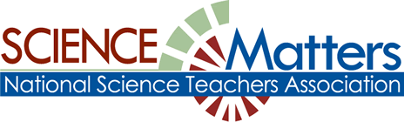

CONNECTICUT SCIENCE CONNECTION
APRIL 2016
The Connecticut Building a Presence for Science Network is sustained through the advocacy of the CCAT, Connecticut Science Supervisors Association, and the Connecticut Science Teachers Association

State Coordinator.David Lopath lopath@comcast.net
List Moderator..Eloise Farmer eloisef302@gmail.com

Names and e-mail addresses of our Points of Contact and Key Leaders are not shared with any other entitY

Resources

NGSS adopted by Connecticut! Training begins in the spring of 2016 in your region. Watch for updates on this CSDE’s science curriculum web site.
Visit the NGSS@NSTA Hub : IT now offers a dynamic version of the Next Generation Science Standards.. Nextgenscience.org


Subscribe to Green Teacher at http://greenteacher.com/subscribe/ <Connecticut Green LEAF Schools> has great lesson ideas that link Common Core with the new Next Generation Science (and they’re fun too!) More information about Connecticut Green LEAF Schools can be found at www.ctgreenleaf.org

Would you like a complete list of grants that has been provided by the National Science Teachers Association? vel. To view this list, please visit:
http://www.nsta.org/publications/calendar/

THE CONNECTICUT ASSOCIATION OF BIOLOGY TEACHERS IDEAS AND INNOVATIONS PROFESSIONAL DEVELOPMENT WORKSHOP! 8:30 AM-3:30 PM APRIL 9, 2016 . Northwestern Connecticut Community College. Details and Registration forms will be posted on the CTABT website (http://web.ccsu.edu/ctabt/ ).
PROFESSIONAL DEVELOPMENT IGNORE THAT DUE DATE! THE JOULE FELLOWS PROGRAM STILL HAS OPENINGS! APPLY TODAY! (I wish I was still teaching so I could go to this great program this summer!)
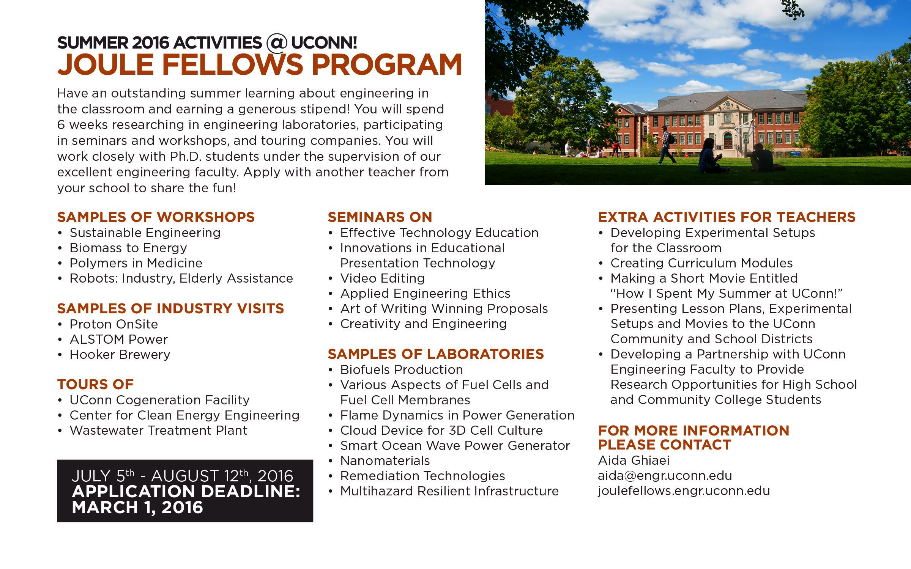

Mystic Seaport for Educators: Mystic Seaport hosts free monthly professional development workshops that provide teachers with “behind-the-scenes” tours and thematic workshops that correlate the Museum’s vast collections with classroom curriculum. Workshops show teachers how to utilize the Museum and its collections in their classrooms through active participation and interaction with experts, primary source documents, and exhibition objects. Topics range from immigration, whaling, and life at sea, navigation and nautical instruments to the Civil War and World War II. Each session will also highlight our website for teachers.

 Celebrate Seminars on Science’s 15th year of teaching and learning with 15% off a summer online course!* Use code CELEBRATE15.
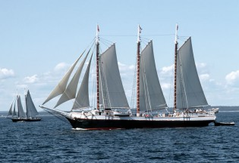
The next session of the American Museum of Natural History’s online teacher education program begins May 23rd. Deepen your knowledge, engage with other science educators, and get access to powerful classroom resources with online courses in the life, Earth, and physical sciences. The 6-week online courses co-taught by world-class museum scientists and classroom educators include The Brain; Climate Change; The Diversity of Fishes; Evolution; Genetics, Genomics, Genethics; The Ocean System; Sharks and Rays; The Solar System and more. Graduate credit is available from our university partners. For more information about the program, check out Seminars on Science at www.amnh.org/learn .

If you have any questions, send us an email at learn@amnh.org, or call us at 800-649-6715
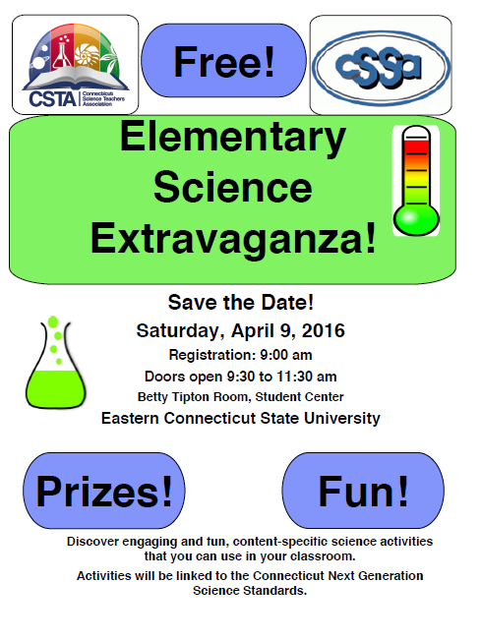
LEADERSHIP AT SEA: PROFESSIONAL DEVELOPMENT FOR TEACHERS
Mystic Seaport and the schooner Victory Chimes are pleased to offer a special joint professional development program for teachers. This is a unique, multidisciplinary teaching and learning experience that is designed to share the resources available to teachers at Mystic Seaport, and to provide an extraordinary environment for learning and connecting with others on board the schooner Victory Chimes, a national landmark vessel that represents our living heritage. This program can accommodate up to 24 teachers. Participating teachers will also learn how they can involve their school in the upcoming Leadership at Sea program for students in 2016-2017.
Shore Component: August 2-4, 2016 at Mystic Seaport
At Sea Component: August 18-22, 2016 on board the schooner Victory Chimes, sailing out of Rockland, ME.
Cost: $1,295/person, includes room and board for entire program (if housing is not needed for shore component, subtract $80) Shore Component at Mystic Seaport (August 2-4, 2016), Mystic CT. Sea Component on board Victory Chimes (August 18-22, 2016), Rockland, ME. Registration Information: Click on: this registration form before April 30, 2016 and let us know if you are paying with a purchase order. Please email registration form to: Kristi Otterbach, Breath Wind expressive arts and education. breathwind11@gmail.com
ETHNICALLY-DIVERSE CONNECTICUT TEACHERS!
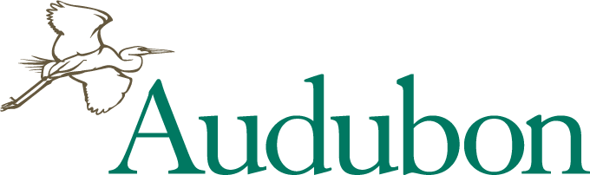
Enhance your environmental education methods and knowledge. We are awarding SIX 80% Scholarships for summer 2016 WHAT: Sharing Nature: An Educators’ Week Workshop WHERE: Hog Island Audubon Camp, Muscongus Bay, Maine
WHEN: JULY 17 - JULY 22, 2016
SCHOLARSHIP: $900 towards $1,095 registration fee (Price includes program, lodging, boat travel, all meals)
Features of Educators’ Week:
- Designed for science and non-science educators to generate exciting ideas for creating and incorporating environmental education activities into your curriculum.
- Inspiring and experienced instructors will share their favorite approaches, methods, and activities for engaging you, and your students, with nature.
- Workshop presentations and guided field trips on the island share techniques in field biology, art, music, photography, theater, journaling, and other disciplines.
Interactive workshop: “Increasing Diversity in Environmental
Education” led by Chandra Taylor Smith, Ph.D. Vice President, , National Audubon Society.
TO APPLY: E-mail letter of interest and names & contact info. of 2 professional references to Camp Director Pete Salmansohn at psalmansohn@audubon.org. Awards given on a rolling basis, so early application is strongly suggested. For details, photos, videos about the camp visit: hogisland.audubon.org.
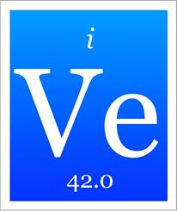
5th Annual STEM Forum & Expo, hosted by NSTA IN Denver: July 27–29, 2016! STEM Forum & Expo hosted by NSTA, brings together educators and organizations who are actively implementing STEM programs in their schools or districts. Held in Denver next July 27-29, come prepared to learn tactics that work, build your professional learning network, connect with effective outreach programs and partnerships, discover new resources, and build a strong curriculum. Keynote Speaker: Derek Muller, Australian-Canadian science communicator, filmmaker, and television presenter created the leading science YouTube channel, Veritasium, that features experiments, expert interviews, cool demos, and discussions with the public about "everything science." Join the over 2 million subscribers and see him in person at the Expo! https://www.youtube.com/user/1veritasium

Tech2Learn What: A Teaching and Learning Technology Event
Where: Quinnipiac University, School of Education North Haven Campus When: Saturday, April 23, 2016, 8:30 AM - 2:30 PM: https://www.eventbrite.com/e/tech2learn-tickets-20999163062
BRING YOUR OWN DEVICE: Technological tools are increasingly available for teachers and students, and new tools can provide lots of “WOW” in a classroom. But how do we go beyond the WOW factor? At Tech2Learn 2016, hosted by the Quinnipiac University School of Education and the Bristol-Myers Squibb Center for Science Teaching and Learning, we’ll explore the use of technology to promote higher-level learning. Schedule: Keynote Speaker, Choice of Morning Sessions, Lunch, Choice of Afternoon Session, Closing with Door Prizes
On the ticket order form, you will be asked to choose either one workshop or two sessions for morning and afternoon. https://www.eventbrite.com/e/tech2learn-tickets-20999163062

THE DEADLINE FOR THE PROJECT SHOWN BELOW WAS GIVEN AS MARCH 4. HOWEVER, THERE MAY STILL BE OPENINGS. TO FIND OUT, please contact: Dr. Stephen Hale, For more information, and to download a packet of information and application visit … http://leitzelcenter.unh.edu/RETE/index.html , or
Email or call 862-4758.
The University of New Hampshire is again offering its very successful Research Experience for Teachers in Engineering progam. STEM pre- and in-service teachers are eligible for this program. Teachers interested to learn and engage more with doing research – asking questions, forming hypothesis, designing research, collecting data, analyzing results, and communicating findings – this is for YOU!! This program is conducted as part of a group of teacher meeting regularly together throughout the summer, while working in separate UNH research groups with faculty, staff, and graduate students. Teachers conduct engineering research and present their research in a poster session.

The goal of this program is to provide STEM teachers with understanding and experience in conducting and participating in STEM research, so that teachers can more effectively bring this experience to their students. This is a full-time summer commitment that begins the week of June 27th and runs through August 12th. There is flexibility for vacation time off (up to 1 week) during this period. This program offers a competitive weekly stipend ($625), room and board (if needed), and mileage reimbursement (up to a set amount). Academic year follow-up sessions focus on enhancement of teachers’ unit lesson plans and inquiry approaches to teaching.

NGSS-JASON SAMPLER FOR TEACHERS OF GRADES 6-8 THURSDAY, APRIL 7, 2016
JASON Learning Professional Development Focused on NGSS: JASON Learning’s comprehensive professional development program is designed to provide educators with the tools and strategies to implement student-driven, in-depth scientific exploration and inquiry. Each workshop is designed to increase educators’ comfort and expertise with providing rich, STEM-based experiences that address State Standards, Next Generation Science Standards, and Common Core. Teachers will put on their “student” hats while experiencing a variety of lab activities, video resources, and digital simulations and learning games, and “teacher hats” while discussing pedagogy, best practices in curriculum integration and implementation, and differentiation for a variety of learners. Workshops also include a tutorial and hands-on practice with navigating the JASON Learning website and understanding how to access resources best directed at their grade specific scope and sequence.
Location: LEARN, Old Lyme, CT
Time: 8:30am-3:30pm
Cost: $25.00
http://www.jason.org/training or
http://www.jason.org/roll-outs/ct-statewide Questions?
Contact: amy@jason.org
June 4, 2016, from 10 am to 3 pm
337 East River Drive, East Hartford, CT 06108
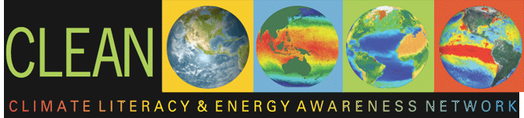
www.CLEANet.org has more than 640 units, lessons, videos, and diagrams While their focus is on Middle and High school, there are some middle school activities that would be appropriate for both. http://serc.carleton.edu/k12/index.html
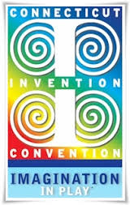
WHEN YOU WALK IN, THEY WILL SAY, “HERE COMES THE JUDGE!”
Which person are you? A HERO - You have already registered as a judge and the students thank you tremendously for your help and support. However, what we need you to do now is to pass this information along to your family, friends and co-workers. If it's good enough for you, won't they enjoy doing it too? In the end, they will thank you!
NOT QUITE YET - We know that you want to be a judge and you are planning to register, but just haven't done it yet. Why wait? You will have a great time. You will help the next generation grow and succeed in school and their careers beyond. You will end the day feeling good about what you've done. But before any of that can happen, you need to register!
NO EXPERIENCE NEEDED
New judges will be teamed with experienced partners
CLICK HERE TO REGISTER http://www.cicregistration.org/judges/

Welcome to Research Quest! Developed as a powerful tool for teachers and serious fun for students, Research Quest is an exciting new program created by the Natural History Museum of Utah (NHMU) that leverages our museum's incredible research and collections with 3D and game technologies - every bit as cool as the newest smartphone apps – to support the development of the critical thinking, collaboration, and communication skills found throughout your core curriculum. http://researchquests.org/ Join our Spring 2016 Pilot Program http://researchquests.org/contact.shtml .

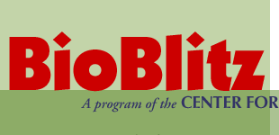The University of Connecticut's Center for Conservation and Biodiversity will be teaming up with the Connecticut State Museum of Natural History, Connecticut Geographic Alliance, and Two Rivers Magnet Middle School to host this year's BioBlitz. Made possible by a grant from the Richard P. Garmany Fund at the Hartford Foundation for Public Giving, this year’s BioBlitz in East Hartford responds to the call from the National Geographic Society and National Park Service for every state to run a BioBlitz in 2016, in celebration of the Park Service’s 100th anniversary.
More than 100 scientists will begin the species survey on Friday at Great River Park, and will canvass habitats found within a four-mile radius of the Two Rivers Magnet School. Surveyors will be sampling the Connecticut and Hockanum rivers, floodplains, forests, freshwater ponds, open fields, as well as more human-dominated and developed areas, and are hoping to catalogue more than 1,500 species.
On Saturday June 4, beginning at 10am, the public is invited to come to the school and participate in a variety of activities. People of all ages are invited to come and see a rich sampling of Connecticut’s plant and animal life, attend presentations about biodiversity, talk with scientists and naturalists, and participate in the ongoing activities.
For more information, call (860) 486-4460.

A great place to hang out! Hubble Hangouts can also be found on HubbleSite:
http://hubblesite.org/get_involved/hubble_hangouts/
Free, Online Access to JASON Learning’s Award-Winning Programs Available to Public School Educators in CT. Through generous support from the Connecticut Department of Economic and Community Development, JASON Learning is providing complimentary access to JASON’s gated website to all public school educators in CT through August of 2017. Each comprehensive JASON program highlights a diverse group of STEM role models, their research and real-world phenomena to engage students and motivate deeper interest in learning. JASON’s online platform includes reading selections, hands-on labs and field assignments, videos, digital simulations and learning games for students; and lesson plans, implementation tips, and a powerful classroom management tool for educators. Live, interactive events throughout the year connect JASON participants with inspirational STEM role models. Educators will have access to a host of downloadable resources from all 7 JASON Learning curricula. Sign-up today by visiting www.jason.org : Logon and create teacher account.

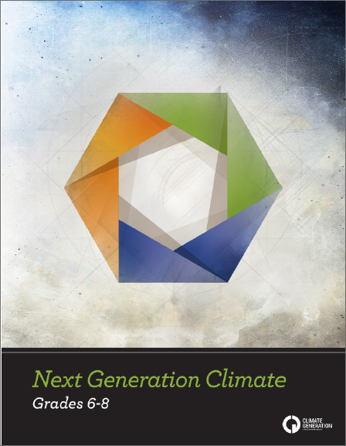
Next Generation Science Standards (NGSS) and the fact that they include climate change. Our newest curriculum, Next Generation Climate for grades 6-8, supports NGSS and we want to help you incorporate both these new standards and climate change into your educational setting. Register today for our 11th annual Summer Institute for Climate Change Education to get hands-on training to teach climate change and network with other educators. http://www.climategen.org/what-we-do/education/professional-development/summer-institute/summer-institute-2016/
JOINT CSTA/CSSA AWARDS BANQUET: JOIN AWARDEES AND HONOR THEIR ACHIEVEMENTS AT THE New Haven Lawn Club on May 5, 5:30 p.m. -8:30 p.m.
Banquet and Presentation of Awards. Cost: $45 per person.
➢ Dr. Sigmund Abeles Science Advocate
Award 2016: Connecticut Invention Convention, CIC, (Ms. Helen Charov, Executive Director),
➢ Connecticut Science Educator Fellow, (CSEF) Award, 2016, Ms. Teresa (Terry) Wilson, Elementary Science Curriculum Specialist for
CREC Magnet Schools
➢ Excellence In Elementary School Science Teaching 2016, Mr. Sean Serafino,
Monroe Elementary School,
➢ Excellence In Middle School Science Teaching 2016, Ms. Beth Manning,
Westside Middle School Academy
➢ Excellence In Secondary School Science Teaching 2016, Ms. Valerie May, Woodstock Academy
➢ The Marty Tafel Student Research
Awardees for 2016 will also be in attendance to receive their awards.
➢ Marty Tafel Student Research Award, Grade 8 Life Science 2016
Analiese Seaman, St. Gregory the Great School
➢ Marty Tafel Student Research Award, Grade 8 Physical Science 2016, Dravyn Okoney, Fields Memorial School, Bozrah
➢ Connecticut Science Supervisors
Association (CSSA) will present awards to outstanding supervisors and leaders for 2016.
Among the awards are:
➢ Fred Scimone Outstanding Science Supervisor Leadership Award 2016, Marianne Malliet. Science Dept. Chair New Britain High School
Presidential Award (PAEMST) 2015 state winners in secondary science and mathematics
➢ Science, Joshua Steffenson
Glastonbury High School
➢ Mathematics
Jacqueline Corricelli, Conard High School, West Hartford
To Register, please click on: http://www.AWARDS_DINNER

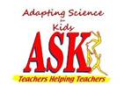
You can find all our newsletters at the Just ASK a Teacher website justaskateacher.com/ or you click HERE to download and print our March 2016 newsletter
We are sharing assessment items for lessons most used by K-6 teachers.
Please share your own assessment items with us at matthewscc@umsl.edu and we will include them in our website and in future newsletters. We are especially interested in assessment items that relate to the Next Generation Science Standards. Our next newsletter will highlight assessment items for “Sound.”

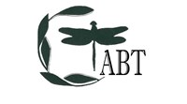
JOIN CTABT Today to connect with fellow life science educators http://web.ccsu.edu/ctabt/membership.html


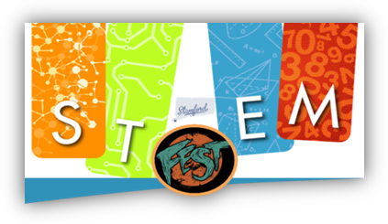
http://bscs.org/digging-deeper PlantingScience: Digging Deeper Together: A Model for Collaborative Teacher/Scientist Professional Development. BSCS, the Botanical Society of America, and the American Society of Plant Biologists are looking for high school life science teachers who are interested in participating in a unique professional development opportunity involving collaborations with research scientists, teachers, and students.
• Are you interested in collaborating with scientist mentors to help students learn how to conduct research on plants?
• Are you interested in taking part in face-to-face and online professional development to help enhance your teaching practices?
• Would you like to participate in a research project to find out how collaborations among teachers, research scientists, and students can lead to enhanced student learning?
• Are you interested in having your students work more with plants?
Digging Deeper is a professional development (PD) research project that builds on the success of PlantingScience, an online science mentoring community for high school biology students.
The Digging Deeper project will develop, implement, and test a professional development (PD) model whereby teachers and scientists work closely together over extended periods to guide students in authentic science investigations and then to reflect on instructional and mentoring strategies that are effective for enhancing student learning.
NEW MATERIALS AND PROJECTS FROM NASA! https://www.nasa.gov/audience/foreducators/index.html
Where: Mill River Park, Stamford/STEMford
When: Saturday, May 14, 2016
(Rain date will be Sunday, May 15, 2016) Time: 10 AM – 4 PM
http://www.stemfest.us/ stamfordstemfest@gmail.com
Visit STEMfest: Date: Saturday, May 14 (rain date Sunday, May 15)
Time: 10am-4pm. Location: Mill River Park, Stamford/STEMford, CT
Cost: Free! What: Activities and displays designed to give preK-12 students and their families a chance to experience STEM (Science, Technology, Engineering and Mathematics) Purpose:
1) To help students and their families learn about what STEM is;
2) To show how much fun these disciplines can be;
3) To show how these disciplines are inherent in many of the things we do every day
4) To share future opportunities available through college and career paths in STEM


Are you a high school teacher looking to give your environmental class a great challenge? Check out the new Our Town Microgrid Challenge for great NGSS engineering connections beyond the usual “….compare and contrast renewables and nonrenewables….” Our Town Microgrid Challenge
What are microgrids and why would you want one? This unit leads students to understand and apply the answers to that question. The unit includes a multiple step process, with industry and policy readings, investigation of town maps and properties, consideration of emergency needs in the event that electric power is lost, and design of a system that will meet that need. Throughout the unit students hold a "public hearing" with their peers to discuss and fine-tune their ideas, and a capstone presentation to town leaders to discuss their solutions in a real-world context. The unit is supported with readings and background information, suggested "building" and energy "generator" cards, and a suggested process to lead students to an understanding of the unit question. This lesson is listed at CT Energy Education www.ctenergyeducation.com


Lunar Workshops for Educators
June 27–July 1
NASA’s Goddard Space Flight Center
NASA's Lunar Reconnaissance Orbiter (LRO) mission is sponsoring a pair of workshops for grade 6–9 science teachers. Each workshop is a week full of lunar science and exploration, complete with tours, presentations and a lunch with NASA scientists, tons of hands-on activities, pedagogical discussions about how effectively to share lunar science with your students – and more!
The workshops are free, and we have a limited number of $500 stipends for those who need financial assistance to participate (available on a first-come, first-served basis to those in need).
All pre-service and in-service grade 6–9 science teachers are encouraged to apply!
More information about the workshops and a link to the applications are available here: http://lro.gsfc.nasa.gov/lwe/index.html

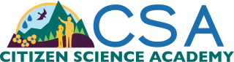

Citizen Science Professional Development for Educators : Are you a formal or informal educator interested in Citizen Science? Learn how to integrate real-life science into your instruction and earn continuing education credits, all from the comfort of your own home! NEON’s Citizen Science Academy (CSA) offers online professional development courses for environmental science educators looking for out-of-the-box ways to teach scientific concepts by immersing your students in collecting, using and interpreting scientific data. By implementing citizen science projects, your students will contribute to research used by scientists all over the country. All CSA courses qualify for graduate-level continuing education credits from Colorado School of Mines.
Ready to learn how to incorporate citizen science projects into your classroom? Register for one of our courses starting April 4th. Learn more at http://CitizenScienceAcademy.org/online-courses. For more information contact: Dennis Ward, dward@neoninc.org , CSA | Course Administrator
NEON | Instructional Designer Boulder, Colorado, http://neoninc.org
http://CitizenScienceAcademy.org



IF YOU TEACH ABOUT MATTER, HERE IS A RESOURCE THAT JUST CAME IN. www.mysteryofmatter.net As you may know, last summer PBS broadcast a series called The Mystery of Matter: Search for the Elements. The three-hour NSF-funded series, which tells the amazing human story behind the Periodic Table, was praised by the press and warmly received by chemistry teachers. “This was one of the most inspirational and educational programs I have ever seen on television,” one teacher wrote. “I applaud PBS for their leadership in developing such wonderful educational shows. I hope there is an effort to ensure that all chemistry students will have this series as part of their curriculum.” After the premiere of The Mystery of Matter, we continued working on the project, using extra grant money we had raised to create a rich collection of educational materials for teachers. They include a Teacher’s Guide aligned with the latest science teaching standards, 60 short clips lifted from the series, and 32 short videos, mostly on topics of interest to chemistry teachers. These resources – all free – live at our website at www.mysteryofmatter.net . (When you get to the site, click on <For Teachers> in the top menu bar.) Having created all this, we’re now working to spread the word so that as many teachers as possible can take advantage of these resources. We’ve already been in touch with NSTA and the American Association of Chemistry Teachers, and they’ll be using their social media and publications to put out the word.

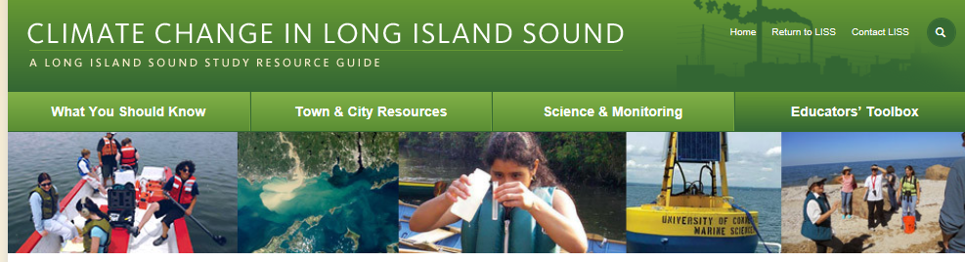
The Long Island Sound Study has created a new website to help Long Island Sound residents, educators, and municipal officials learn more about climate change issues that can impact Long Island Sound.
Climate Change in Long Island Sound: A Long Island Sound Resource Guide, at www.lissclimatechange.net, is divided into four sections:
• What You Should Know — a primer on key concepts about climate change as well as access to web resources, including indicators of climate change in Long Island Sound.
• Town and City Resources — a portal providing links to what communities are doing to adapt to climate change and reduce greenhouse emissions, including cases studies from five Long Island Sound communities.
• Science and Monitoring — examples of research and monitoring being conducted in Long Island Sound.
• Educators' Toolbox — Resources for teaching about Earth's climate system and the changing climate, including "Science Spotlights" of local scientists conducting climate change research, and highlights of a teachers' workshop on climate change (note: we hope to work with scientists as well as other resource managers to include more "spotlights" and other features in the future).
Besides the four theme's the website's homepage includes a "newsroom" with two climate change newsfeeds, and a list of "hot" links for more climate change information.
The project was initiated by Long Island Sound Study's Sentinel Monitoring for Climate Change program, and includes representatives from the Connecticut and New York Sea Grant Programs, the Connecticut Department of Energy and Environmental Protection, the New York State Department of Environmental Conservation, NOAA's Northeast Fisheries Division, Milford Laboratory, and the New England Interstate Water Pollution Control Commission.

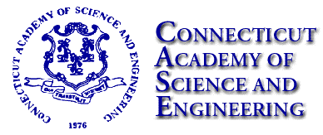TO: CASE Bulletin Readership
The 2016 CASE Spring Bulletin is now available. To access, click the following link: http://www.ctcase.org/bulletin/31_1/31_1.pdf
CASE Bulletin Spring 2016 Edition Volume 31,1
In this issue:
• In the White House Office of Science and Technology Policy: Crafting National Science Policy, Advising a President
• CASE Members Laurencin, Rothberg Receive National Medal of Technology and Innovation
• Connecticut State Museum of Natural History at UConn
• News from the National Academies:
o Study Examines Barriers in STEM 'Educational Pathways'
o Report Urges New Approach to Affordable Flood Insurance
o Assessing Hurricane Risk in a Changing Climate
o Examining Interregional Travel Policies
• In Briefs: Science and Technology News from Around the State

PROGRAMS FOR STUDENTS:
May 1, 2016: Deadline for students 13 – 19 to enter the Future Engineers “Star Trek” Replicator Challenge. Please visit:
http://www.futureengineers.org/startrek

May 2, 2016: Deadline for MS and HS Students to apply to participate in the Mission Imagination (STEM/ISS) Design Challenge. Please visit:
https://education.ti.com/html/Nasa/overview.shtml

May 16, 2016: Deadline for Students ages 9 – 18 to apply for the $3000 Brower Youth Award. Please visit: http://www.scholarshipguidance.com/scholarship_brower_youth_award_8974.php?&utm_source=newsletter01&utm_medium=email&utm_campaign=201603&utm_content=4ab258778f736ac551699e89a48ba9b4

May 18, 2016: Deadline to enter the Google Science Fair for students ages 13 – 18. Please visit:
https://www.googlesciencefair.com/en/
May 31, 2016: Deadline for Middle School and High School Students to enter the National Academy of Engineering 3rd Annual Engineering for You Video Contest Grand Prize - $25,000 Please visit http://www.nae.edu/e4u3/?mc_cid=e71acba515&mc_eid=5639c29c07

I am currently deployed at Palmer Station, Antarctica and I want to invite you and your school (or institution) to follow our outreach website called A Fly on the Pole. Funded by the National Science Foundation, we are studying the largest land animal in Antarctica...any guesses? It's a wingless fly!
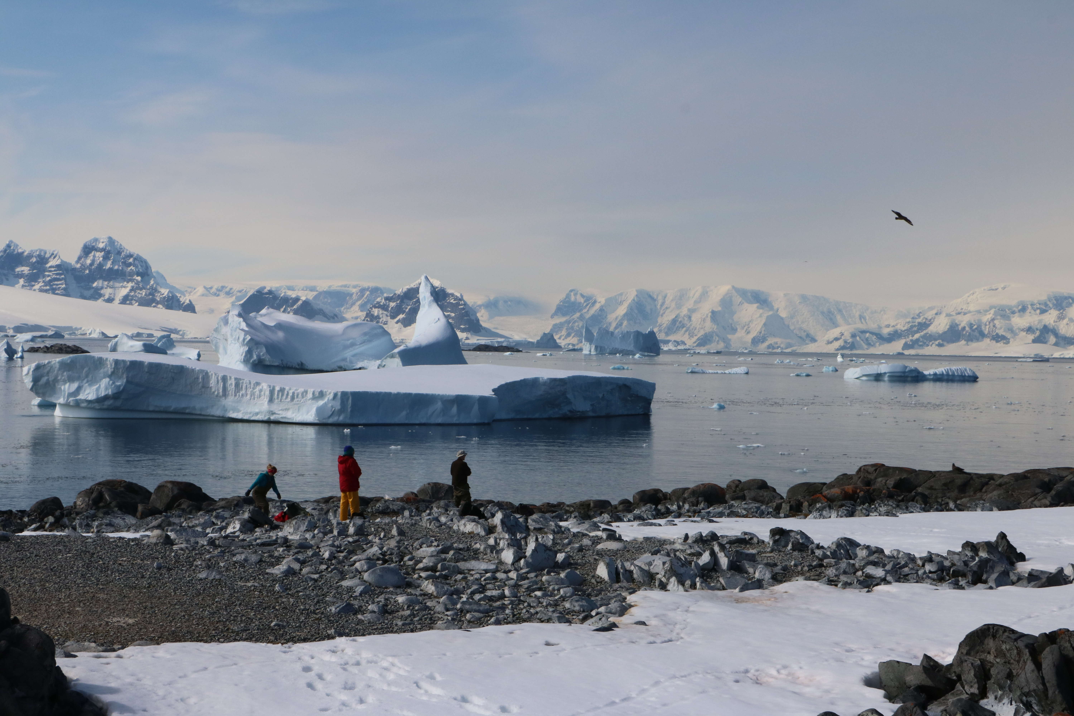
A Fly on the Pole: 2016 Antarctic Research Expedition: Antarctica is a tough place for any critter to make its living. The continent is one of the coldest, driest, and windiest places on Earth. But nestled among the moss and the rocks of the Antarctica Peninsula lives a tough little fly with amazing adaptations. We invite students, teachers, community members, and science enthusiasts to join us as we travel to Palmer Station, Antarctica to learn more about how Belgica antarctica survives harsh polar conditions. As an educator, I am thrilled for the opportunity to help you and your students connect with this extraordinary experience! I will be updating the blog portion of the website daily - with breathtaking photos, movies, and personal accounts of our Antarctic expedition. There are also a variety of resources on the site for K-12 educators. Please leave a comment on the blog so I know you are following along! There is also a webpage for educators called "Get Connected" to receive "A Fly on the Pole" updates. http://www.aflyonthepole.com Natalie Harr Ylizarde, Doctoral Student Teaching, Learning, Policy, and Leadership (TLPL), ylizarde@umd.edu

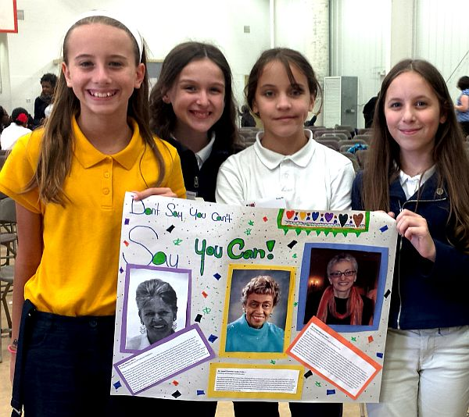
New Women in STEM Resource Available The Connecticut Women's Hall of Fame is pleased to announce the release of STEMfems: Women Transforming Our World, a new module in our award-winning DIY History series. Specifically designed to help educators bring women's perspectives into the classroom, STEMfems includes Common Core-aligned information and activities related to pioneering Connecticut women in diverse STEM fields from 3D printing and architecture to biology and astronomy. Training and support in how to incorporate STEMfems content into your existing lesson plans is also available from CWHF staff. Register and download STEMfems today by visiting www.cwhf.org/DIY! It's free! Contact Bambi Mroz, Director of Education, for more details or with any questions (203-392-9013 |).

HOW TO RECEIVE THIS NEWSLETTER BY BECOMING A POINT OF CONTACT.

We welcome new recipients to NSTA’s Science Matters network! Please click on: http://bap.nsta.org/ and sign up! You will receive information from NSTA and get this State newsletter each month. You can also email me at eloisef302@gmail.com so that I make sure you are on our mailing list. NSTA sends our newsletter to all the recipients on our State list of Points of Contact. Please join us!

What Is Science Matters? Science Matters is an initiative by the National Science Teachers Association (NSTA) to bring content, news, and information that supports quality science education to parents and teachers nationwide. Science Matters builds on the success of the Building a Presence for Science program, first launched in 1997 as an e-networking initiative to assist teachers of science with professional development opportunities. Building a Presence for Science—now Science Matters—reaches readers in 34 states and the District of Columbia. Why does Science Matter? Science is critical to understanding the world around us. Most Americans feel that they received a good education and that their children will as well. Unfortunately, not many are aware that international tests show that American students are simply not performing well in science when compared to students in other countries. Many students (and their parents!) believe that science is irrelevant to their lives. Innovation leads to new products and processes that sustain our economy, and this innovation depends on a solid knowledge base in science, math, and engineering. All jobs of the future will require a basic understanding of math and science. The most recent ten year employment projections by the U.S. Labor Department show that of the 20 fastest growing occupations projected for 2014, 15 of them require significant mathematics or science preparation to successfully compete for a job. This is why Science Matters. Quality learning experiences in the sciences—starting at an early age—are critical to science literacy and our future workforce. Feel free to publish this information in school newsletters and bulletins, and share it with other parents, teachers, and administrators.

