**ENGINEERING MAKES IT WORK!**

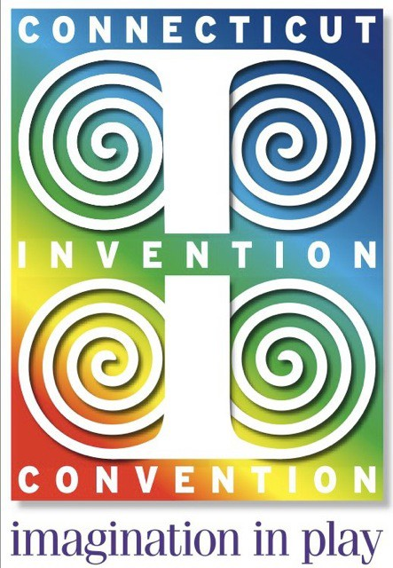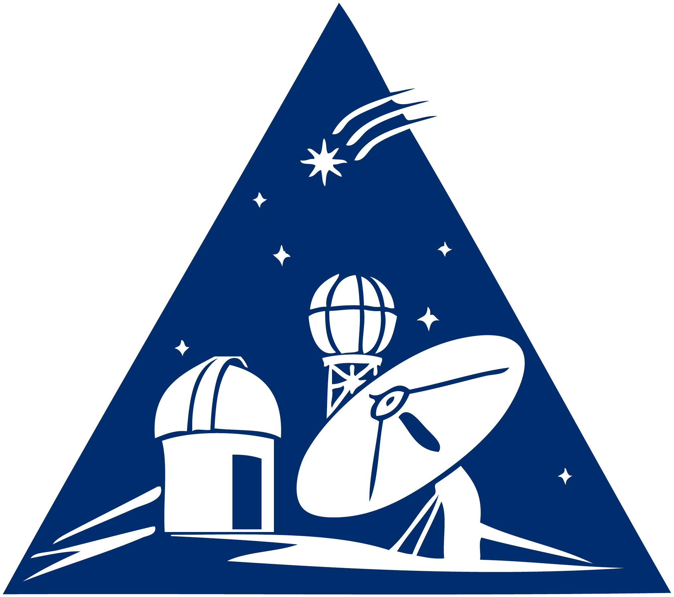

**Talcott Mountain Science Center and Connecticut Invention Convention** team up to bring you hands-on workshops on how to mentor your Invention students

When: Saturday, October 25, 2014, 9:00 - 3:00

Where: Talcott Mountain Science Center

324 Montevideo Rd., Avon, CT

Who: K-8 Teachers and Informal Science Educators

What: Introductory workshop, teachers do not need any

previous skill or knowledge.

**Part I- You will be able to:**

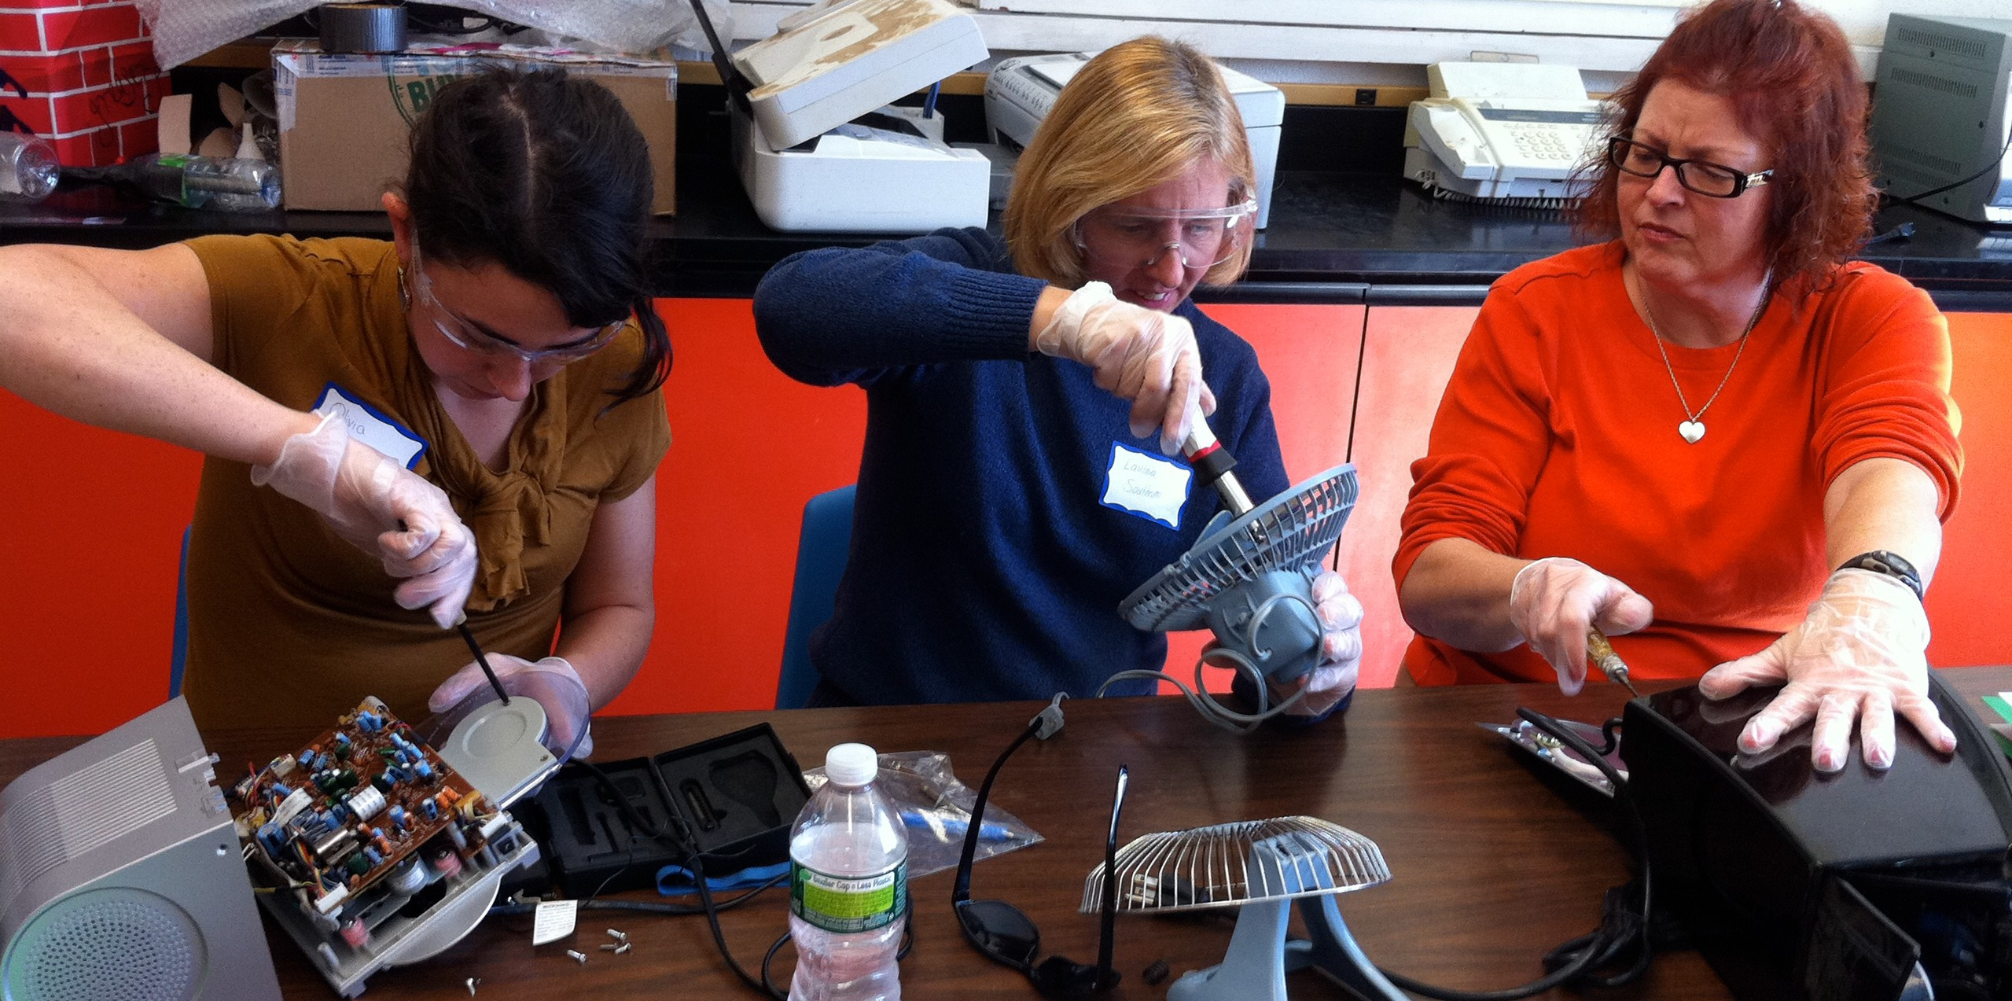

•Address Next Generation Science

Standards

•Apply basic engineering process

through student inventions

•Develop basic skills in

electronics and material science

**Part II: 3D Design:-You will be able to:**



• Use free software to design an invention

• Use a 3D Printer

• Print an object to take home!

All you need is curiosity and a desire to learn! Workshop content is linked to the Next Generation Science Standards.

Cost: $55 includes both workshops and lunch

($5 discount for registered CIC teachers)

Register Online at: tmsc.org/tmsc-cic or call: 860-677-8571

Visit us at tmsc.org and ctinventionconvention.org