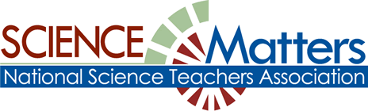

CONNECTICUT SCIENCE CONNECTION
February 2015
The Connecticut Building a Presence for Science Network is sustained through the advocacy of the CCAT, Connecticut Science Supervisors Association, and the Connecticut Science Teachers Association

State Coordinator.David Lopath lopath@comcast.net
List Moderator..Eloise Farmer eloisef302@gmail.com

Names and e-mail addresses of our Points of Contact and Key Leaders are not shared with any other entit

Resources
CSDE’s science curriculum web site.
More on Standards at: http://www.nextgenscience.org/

EQuIP Rubric for Science Released! The Educators Evaluating the Quality of Instructional Products (EQuIP) Rubric for Lessons & Units: Science provides criteria with respect to the NGSS.
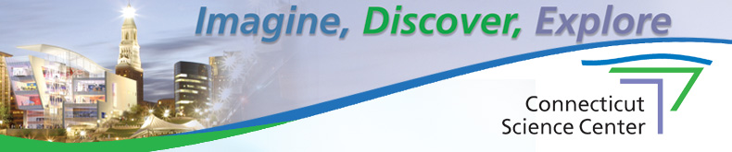
To get all the latest happenings at the Connecticut Science Center, click on the link to its newsletter. www.ctsciencecenter.org/newsletter/
Visit the NGSS@NSTA Hub :
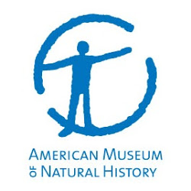
The NGSS@NSTA Hub now offers a dynamic version of the Next Generation Science Standards.. Accompanying each standard are student performance expectations, and the corresponding science and engineering practices, disciplinary core ideas, Connections to Common Core Standards! Teachers need resources that are quick and easy to access. Get the latest information at: http://nstacommunities.org/blog/2014/11/10/new-from-nsta-quick-reference-guides-to-the-next-generation-science-standards/

For the latest from Connecticut about Science testing and Standards, read the news from Liz Buttner, our State Science Coordinator beginning on page 7 of this newsletter.

CONNECTICUT NAMED A TOP 5 FUEL CELL STATE: In its recent report State of the States: Fuel Cells in America 2014, the US Department of Energy recognized Connecticut as a fuel cell leader. This report details fuel cell and hydrogen policies across the country. Efforts by our Science Matters advocate CCAT, along with its administrated Connecticut Hydrogen-Fuel Cell Coalition (CHFCC) to improve resiliency of the power grid and work with stakeholders to promote fuel cell use have led to funding from the Department of Economic and Community Development (DECD). Major fuel cell advances are taking place as Bridgeport became home to the largest fuel cell power station in the US, manufactured and installed by a fuel cell energy plant located in Torrington. When teaching about energy resources, it could be noted that Connecticut leads the Northeast region as nearly 600 Connecticut companies are part of more than 1170 industry businesses in New England, New York, and New Jersey, and have generated more than half the revenue in the Northeast region. Source…January 4 Hartford Courant section H7, page 5.

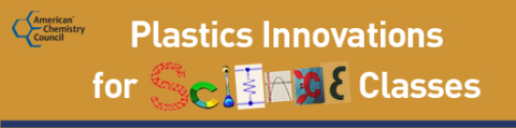

Dress made with 3D printer, palms like a gecko with polymers!
http://elink.azuresend.com/m/37d7bd60f0e1477ca0f123c041f83fb6/D55C44AE

OPPORTUNITIES FOR TEACHERS:

The next session of Seminars on Science, the American Museum of Natural History’s online professional learning program for educators begins March 16th. Graduate credit is available. Enroll now at learn.amnh.org.

The six-week online courses co-taught by experienced scientists and educators include Evolution; Genetics, Genomics, Genethics; The Solar System, Water and many more. Get access to cutting-edge research, rich content, and powerful classroom resources.

Sign up today and receive $50 off your registration cost! Use code SCIENCEMATTERS. For more information about the program, check out Seminars on Science at learn.amnh.org .

If you have any questions, send us an email at learn@amnh.org , or call us at 800-649-6715.
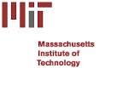

MIT CLUB OF HARTFORD
Every June, MIT offers a one-week program for teachers on “science and technology” at the campus in Cambridge, Massachusetts. It’s called the MIT Science and Engineering Program for Teachers (SEPT). Many teachers in the Greater Hartford area have attended the course over the years and have given it rave reviews. A description of the program is available at the website: http://web.mit.edu/scienceprogram/program.html. The MIT Club of Greater Hartford is offering a scholarship to a teacher in this area who wishes to attend the SEPT program. All you need to do is send your application to us by February 14th at the address listed below and we will select who will receive our scholarship. The application form is given at: http://mit.us4.list-manage2.com/track/click?u=0d1e2e201ebe2552f55e43748&id=ff5f2606cc&e=f131bb19d1.

Workshop at Project LEARN, Tectonic Fury: Geology Unit. Incorporate NGSS Science & Engineering Practices with JASON Learning, March 26, 2015, 8:30am - 3:30pm, LEARN, 44 Hatchetts Hill Road, Old Lyme, CT 06371. Register Today! Registration Fee: $25.00. This workshop offers an opportunity for educators to gain hands-on practice with labs and digital resources, and participate in science standards discourse. Educators will have access to a host of downloadable resources from all 6 JASON Learning curricula and will understand how to access and use then with students after participation.
https://gallery.mailchimp.com/a8e8fe4bb836787077844ed29/files/JASON_Learning_LEARN_wrkshp_flyer_2014_5.pdf
Bitten! Actress Lindsay Lohan Contracts Chikungunya Virus in Bora Bora
Climate Change and Insect-Borne Disease Investigations
Yale Peabody Museum of Natural History DEADLINE: March 31, 2015
BREAKING NEWS: Lindsay Lohan contracted the mosquito-borne chikungunya virus last month while vacationing in French Polynesia. www.webmd.com/news/20141231/lindsay-lohan-chikungunya Chikungunya (“that which contorts”) was first identified in Africa in the 1950s and has since expanded into the Indian Ocean region, southeast Asia and the Pacific Islands. Last winter the virus emerged and spread rapidly through the Caribbean. The first locally transmitted cases of chikungunya in the U.S. appeared in Florida last summer. Two mosquito species - Aedes aeqypti and Aedes albopictus - can transmit the virus. Symptoms include severe joint pain, high fever, and flu-like symptoms. No cure or vaccine exists, and prevention is limited to avoidance of mosquito bites. We invite grade 7-12 science educators to teach standards-based STEM curriculum mini-units in the classroom. Yale Peabody Museum and Connecticut teachers designed modular units about climate’s effect on the spread of emerging insect-borne diseases such as dengue fever, West Nile virus, chikungunya and malaria. How does an infectious disease establish itself in a new environment? Does climate change play a role? Could chikungunya be the next major insect-borne disease epidemic in the US? For other tropical insect-borne diseases on the move, see: www.healthline.com/health-news/kissing-bug-disease-chikungunya-and-dengue-in-us-112014#1
Lessons address middle and high school life science standards:
- experimental design
- structure and function; size and scale
- microorganisms; immune system and infectious diseases
- ecosystem change; ecology and population dynamics

(NOTE Track 1 vs. Track 2 levels of participation)

Benefits for teachers :
- FREE 3-day Summer Institute: July 8-10, 2015
- FREE science kit and standards-based curriculum mini-units
- Peabody Museum family membership and free admission to 280 science museums
- 26 hours credit toward state-mandated professional development
- TRACK 1: $300 stipend after teaching and assessing entire mini-units in your classroom
- Required ½ day weekend follow up workshop in Fall 2015
- Ongoing classroom support from museum educators
- One FREE class visit to the Peabody or the CT Agricultural Experiment Station mosquito lab
- OR TRACK 2: $100 stipend after teaching 5 selected lessons and providing on-line feedback
Funded by a Science Education Partnership Award (SEPA) from the National Institutes of Health. SEPA projects immerse students in science practices; increase science literacy and numeracy; and encourage biomedical careers and partnerships between scientists and educators. To apply, visit http://peabody.yale.edu/climate-summer (deadline: March 31, 2015).

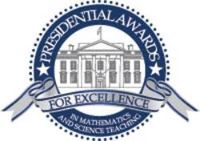
Presidential Awards for Excellence in
Mathematics and Science Teaching (PAEMST). NOMINATE A GRADE 7-12 TEACHER OF SCIENCE, MATHEMATICS or COMPUTER SCIENCE. There are outstanding science and mathematics teachers in every school system throughout Connecticut, including charters, magnets and independent schools. Eligible teachers must have completed 5 years of K-12 teaching prior to this year and currently be teaching science (including computer science) or mathematics in Grades 7-12. NOMINATE NOW at www.paemst.org (click on “Nominate a Teacher”). Anyone may nominate – principals, colleagues, parents, students or members of the general public. Qualified teachers may also self-nominate.
PAEMST recognizes teachers who incorporate innovation and creativity in their classroom teaching, make significant contributions to curriculum development, and demonstrate leadership within the education community. You may nominate several teachers whose work you know well, even if they do not teach in your school. Passion for science (including computer science) or mathematics, together with ability to energize students’ enthusiasm for learning these subjects, are among the qualities to look for in nominees. Give your nominees plenty of time to complete the rigorous application that includes a written narrative, a videotaped lesson and letters of recommendation.
APPLICATIONS ARE DUE BY MAY 1, 2015. Once nominated, teachers must access www.paemst.org to certify their eligibility and to learn more about the program.
Thank you for your support,
Liz Buttner, State Coordinator- PAEMST Science.

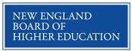
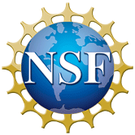
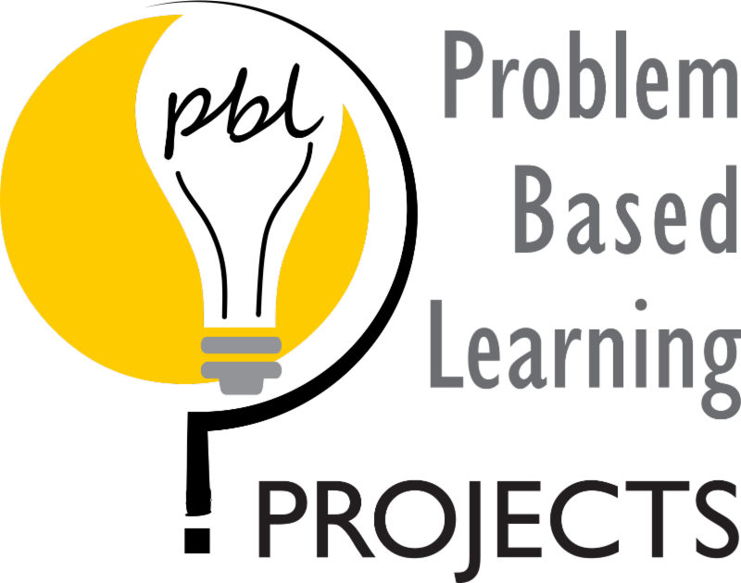

You're Invited! Attend NEBHE's AM PBL Workshop and SME's Bright Minds Program at EASTEC 2015
May 13, 2015, West Springfield, Massachusetts, (Co-located at EASTEC)

SME's Bright Minds reinforces the value of education in manufacturing careers by showcasing real world outcomes and results to middle school, high school, and college students, educators, and administrators. The Bright Minds program will feature NEBHE's AM PBL workshop and The Dream It! Do It! Student Challenge.
• Participants in NEBHE's Advanced Manufacturing Problem Based Learning (AM PBL) Workshop will learn how to use the AM PBL multimedia Challenges, developed in collaboration with New England manufacturers. Participating educators will learn how to work with industry partners to enhance student's content knowledge, critical thinking skills and ability to work in teams. Full registration for the PBL program and other workshops will be available in February 2015 at www.easteconline.com.
• Students, educators, administrators, and councilors are invited to participate in SME's Bright Minds Dream It! Do It! Manufacturing Student Challenge. Student teams and individuals can submit a project entry to membership@sme.org with team name, school, challenge choice (challenge options, details and agenda are at easteconline.com), and the name and contact information (phone and email) for the main educator/chaperone. Teams can be no less than 3 students but no more than 6 students.
o Project entries are due by Friday, February 20, 2015.
o Cash prizes and awards will be presented to the winning teams and individuals. A stipend for travel expenses and lunch will be provided (details to follow).
o Questions, please email Dolores Nixon at dnixon@sme.org.
Register your students and school for SME's Bright Minds Dream It! Do It! Student Challenge today by sending an email to membership@sme.org.

Full registration for the AM PBL workshop and other programming will be available in February 2015 at www.easteconline.com .
Questions? Please contact Project Coordinator Becky Eidelman at reidelman@nebhe.org or by phone at 617-357-9620 x 113.

The PBL Projects of the New England Board of Higher Education are funded in part by the National Science Foundation's Advanced Technological Education program (DUE Numbers 1204941, 0903051, 0603143).

CT SCIENCE SAFETY NETWORK WORKSHOP SERIES:
- February 12 – STEM Safety (new)
- March 5 – Safety in the Arts (new)
- March 19 – Science Safety for Special Education Teachers and Paraprofessionals (new)
FOR INFORMATION, CONTACT: Sara MacSorley, Director of the Green Street Arts Center and Project to Increase Mastery of Mathematics and Science (PIMMS ) smacsorley@wesleyan.edu 860-685-7870:
The National WWII Museum is excited to announce a week-long professional development opportunity to take place in the summer of 2015 for middle school (5-8th grade) science teachers. Twenty eight teachers from across the country will come to New Orleans to experience hands-on how necessity, knowledge, perseverance and skill lead to inventions, innovation, and careers in STEM—just like in World War II.
This seminary is supported by a grant from the Northrop Grumman Foundation. Teachers will receive free room and board in New Orleans, a travel stipend, and all seminar materials free of charge.
We are looking for great young teachers nationwide, and the application period begins January 5th 2015. Please visit http://www.nationalww2museum.org/realworldscience for more information and to sign up for email updates.

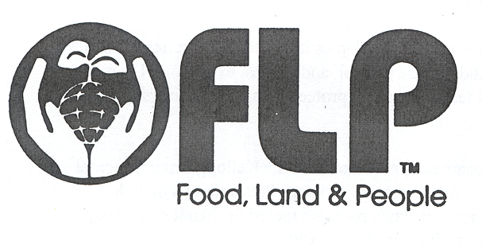
Project Food, Land and People is designed to provide educational materials emphasizing natural resources, soils, food, nutrition, and food systems. It promotes an educational approach that allows students to understand the large picture of the interrelationships among, natural resources, agriculture, the environment and the people of the world, while meeting National and State education standards and applying personal choice. Workshops provide participants with classroom ready activities and supporting materials along with local contacts and materials to help integrate concepts into classroom needs. Contact susan.quincy@ct.gov , 203-734-2513. Workshop fee is $40.00 for any workshop,
.
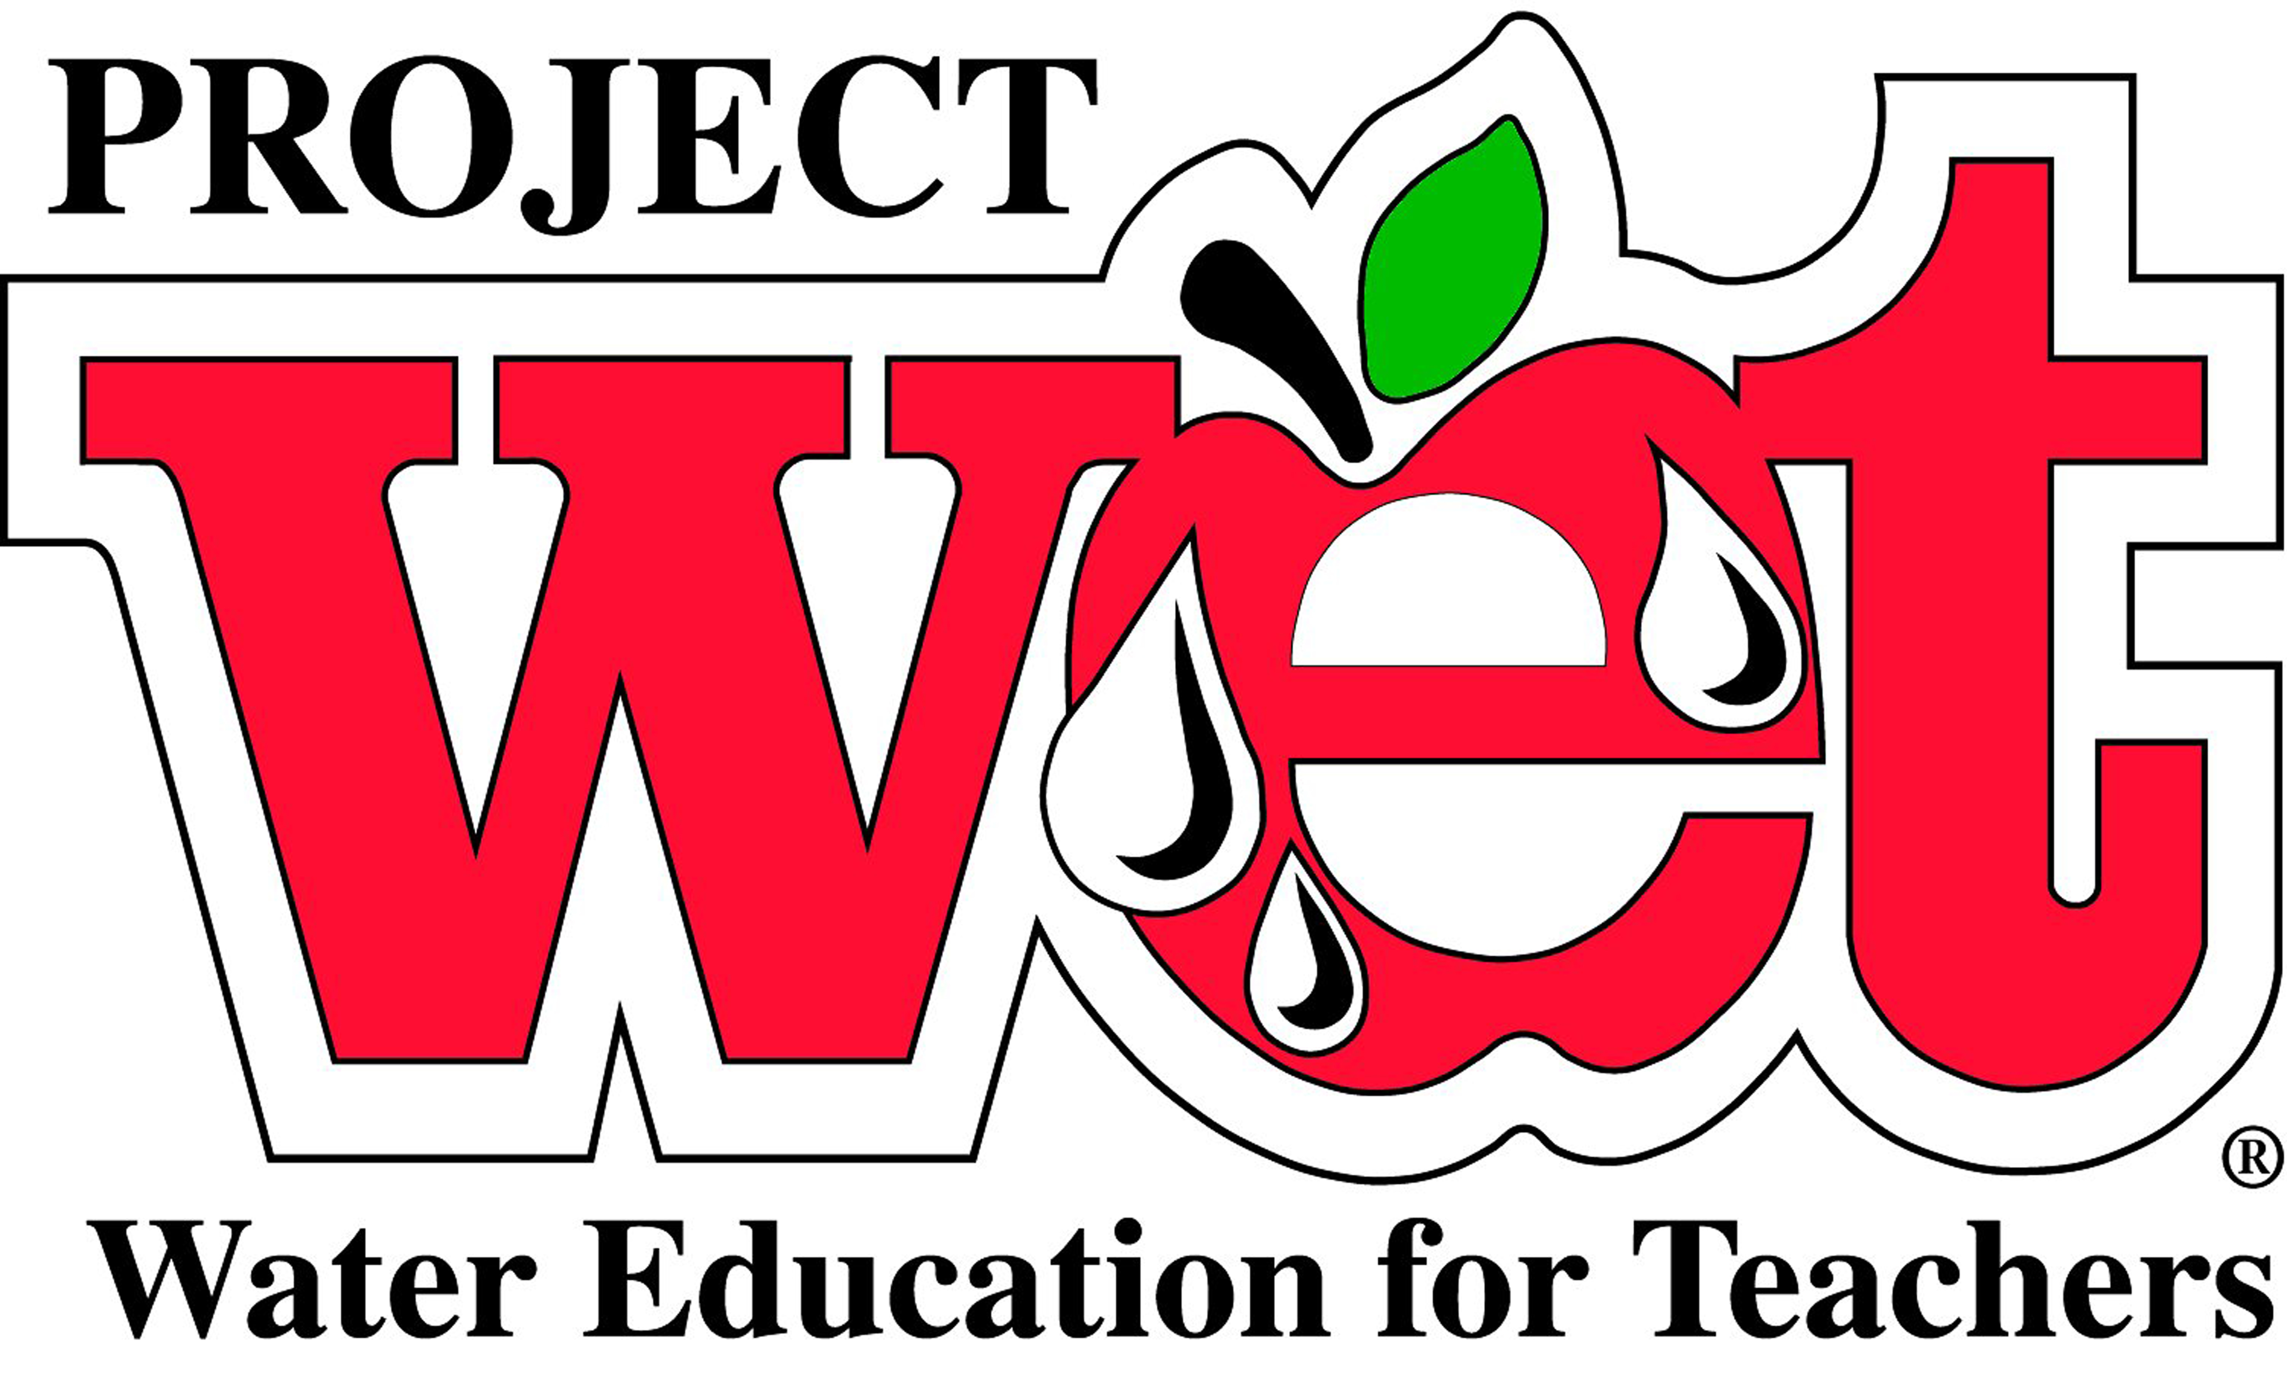
February 11, 2015
Eat Well Be Well
9:00 am – 3:00 pm
Kellogg Environmental Center
500 Hawthorne Ave., Derby, CT

The New Year has started and how is that resolution doing? Help students understand the basics of nutrition and the pathway of nutrients from environment to us. Learn how to connect cafeteria activities and support new lunch standards through better nutrition in the classroom. This educational resource has great connections to Common Core math and Literature standards with activities that apply to grades k-12.
March 11, 2015
Workshop
9:00 am – 3:00 pm
James L. Goodwin Conservation Center
James L. Goodwin State Forest
23 Potter Road, Hampton, CT 06247

Use this day of professional development to delve into how agriculture affects us and we affect agriculture. Focus will be on increasing agriculture and environmental literacy beginning with soil and water and ending with human populations and sustainability issues. Activities are provided for K-12 that increase understanding of natural resource use, technology and design, land use choices, and nutrition. All activities support the Common Core standards and NGSS.
Registration for workshops is required. Fee $40.00 per participant.
Registration forms available by emailing
Susan Quincy at susan.quincy@ct.gov or call 203-734-2513
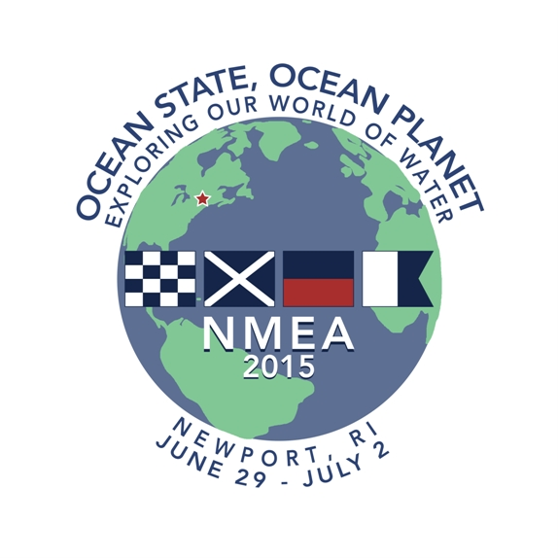
What is NMEA 2015? June 29 - July 2, 2014 SENEME, SouthEastern New England Marine Educators is proud to be the host of the 2015 National Marine Educators Association annual. You can choose the days you would like to attend –or just one day -to concentrate on the strand that interests you most or all or up to five days to absorb the full impact of marine science education; from lectures and workshops to our vast array of experiential learning opportunities in the Newport Area.
Join us at the Newport Marriott, June 28 to July 2, 2015. The National Marine Educators Association Annual Conference is attended by both formal and informal educators, and students from public and private institutions as well as from aquariums, for profit and nonprofit organizations including government agencies. This three to five day event will be filled with an amazing amount of current marine science information. Some of which is related to STEM education and next generation Science standards.
More information can be found online At the NMEA site
http://marine-ed.site-ym.com/general/custom.asp?page=NMEA_2015 Or on our site SENEME http://seneme.org

Grants and Resources For K-12 Teachers

Connecticut Green LEAF Schools has been awarded a Teacher Quality Partnership Grant through the CT Office of Higher Education. . More information about Connecticut Green LEAF Schools can be found at www.ctgreenleaf.org
*********************************************
Would you like a complete list of grants that has been provided by the National Science Teachers Association? NSTA has put these grant and their deadlines in an easy to follow calendar. It includes: deadline date, description, category, and grade level. To view this list, please visit:
http://www.nsta.org/publications/calendar/

A Science Argumentation rubric has been developed by Mary Lou Smith and her colleagues. If anyone tries it out, they would really like to get some feedback! To get a copy, you can request an updated one by email from Eloise Farmer at eloisef302@gmail.com

Interested in science opportunities available in Michigan? Check this out.. http://bap.nsta.org/Attachments/eBlast01232015.docx

OPPORTUNITIES FOR STUDENTS
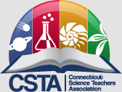
OUTSTANDING HIGH SCHOOL SENIORS INVITED TO APPLY FOR
2015 NATIONAL YOUTH SCIENCE CAMP® HONORS
Governor Dannel Malloy invites outstanding Connecticut high school seniors to apply to represent our state at the National Youth Science Camp (NYSC) in West Virginia, from June 17 to July 11, 2015. Each year, West Virginia’s Governor invites the governor of each state to appoint a selection coordinator to oversee a competitive process to choose that state’s NYSC delegates. Connecticut’s NYSC program is jointly coordinated by the Connecticut State Department of Education (CSDE) and the Connecticut Science Teachers Association (CSTA).
NYSC is a residential science education program that honors and challenges two graduating high school science students from each state. The NYSC is held near Bartow in the eastern mountains of West Virginia, within the Monongahela National Forest. Scientists from across the nation present lectures and hands-on science seminars and linger to interact informally with student delegates. Delegates are challenged to explore new areas in the biological and physical sciences, art, and music with resident staff members. Opportunities are provided for delegates to present seminars covering their own areas of interest and research. A visit to Washington D.C. permits delegates to visit some of the nation’s premier scientific, governmental, and cultural facilities. The NYSC experience includes overnight excursions into the Monongahela National Forest featuring backpacking, rock-climbing, caving, mountain biking and kayaking opportunities. Delegates are required to participate in the camp program for its entirety as the full schedule of activities and remote location make travel to and from the site difficult.
This year NYSC delegates will arrive in Charleston, West Virginia, on Wednesday, June 17, and depart on Saturday, July 11, 2015. Delegates must be available to attend the entire camp session.
Information about NYSC is found at www.nysc.org; eligibility information and application are at http://apply.nysc.org. Applications must be submitted online by Friday, March 1, 2015. Applications from Connecticut high school seniors are evaluated by a committee overseen by CSTA using criteria provided by the NYSC.
The NYSC experience is offered at no cost to its participants thanks to the fund-raising efforts of the National Youth Science Foundation®. Educational and recreational programming, as well as meals, lodging, and round-trip air passage on scheduled airlines are provided free of charge for selected delegates.
FOR MORE INFORMATION, CONTACT:
Dr. Terry Contant, Connecticut’s NYSC Selection Coordinator, at 860-434-4800 x 172 or tcontant@learn.k12.ct.us

ait World of 7 Billion Contest
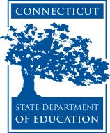
Create a short video (up to 60 seconds) about human population growth that highlights one of the following global challenges.
- The world is in the midst of the sixth mass extinction.
- Most of the world’s suitable farmland is already under cultivation.
- Worldwide, 1 in 10 primary school age children and 1 in 3 secondary age children are not enrolled in school.
All videos must include a) how population growth impacts the issue, b) why the issue is important, and c) at least one idea for a sustainable solution.
Deadline for video submissions: Thursday, February 19, 2015 (5:00pm Eastern US time)
NEW CHALLENGE! Chemical Educational Foundation® (CEF), a nationally recognized non-profit organization dedicated to enhancing grade K-8 students’ appreciation of the science and value of chemistry. CEF has created a series of You Be The Chemist® (YBTC) programs, including the YBTC Challenge, an academic competition for grade 5‒8 students. The YBTC Challenge engages grade 5‒8 students in learning about important chemistry concepts, scientific discoveries, and laboratory safety. The Challenge is organized into three competitive levels: local, state, and national. Local and state competitions take place throughout the school year, and culminate in a national competition held each June in Philadelphia, PA (see our YouTube video). This year the Challenge will celebrate its tenth anniversary with over 23,000 participants in 30 states. Connecticut currently has three Local Challenge sites in New Haven County, Fairfield County, and Waterbury. For more information, including information about our YBTC Activity Guides (available for FREE online download) www.chemed.org.

SPACE DAY IN CONNECTICUT! Applications are welcomed from schools interested in getting $500-$1000 to fund a program for Space Day in CT, which is March 29, 2015. All you have to do is send us a 1 page proposal on a program you’d like to run—can be anything relating to space in order to promote Space Day. Please send me a proposal! Thanks again.
Beth A. Taylor, PhD
Assistant Professor, Health Sciences
Assistant Director, CT Space Grant Consortium
Director, Center for Health, Care and Well-being
University of Hartford
http://www.uheart.wordpress.com
860.768.4831 and betaylor@hartford.edu

Final Call: For Schools and School Districts - Student Spaceflight Experiments
Program (SSEP) Mission 8 to the International Space Station

A Community Engagement Model for Grade 5-14 Authentic STEM, Starting February 23, 2015! The National Center for Earth and Space Science Education and the Arthur C. Clarke Institute for Space Education invite schools, school districts, and community colleges to explore participation in Student Spaceflight Experiments Program (SSEP) Mission 8 to the International Space Station.
This STEM education opportunity immerses grade 5-14 students across a community in an authentic, high visibility research experience, where student teams design and propose real microgravity experiments to fly in low Earth orbit on the International Space Station (ISS). The program nurtures ownership in learning, critical thinking, problem solving, navigation of an interdisciplinary landscape, teamwork, and communication skills – all reflective of the Next Generation Science
Standards, and reflective of the skills needed by professional scientists and
engineers.
Each community participating in SSEP is provided a real research asset – a
flight certified, straightforward to use microgravity research mini-laboratory,
and launch services to transport the mini-laboratory to ISS. It is a limited
research asset given that the mini-laboratory can only contain a single student
team designed microgravity experiment. An astronaut aboard ISS will conduct the
experiment, and after a 6 to 12-week stay in orbit, the experiment will be
returned safely to Earth for harvesting and analysis by the community's
student flight team.
Mirroring how professional researchers formally compete to obtain limited
research assets, the participating community carries out a "call for
proposals”. More specifically, the community conducts a local Flight
Experiment Design Competition. First, a core group of the community's STEM
educators engage typically 200 students in a microgravity curriculum provided by
the Center. The students are then separated into teams of typically 3-5 students
per team, with each team vying for the community's single flight experiment
slot by designing, then formally proposing, a microgravity experiment in a
science discipline of their choice. Their experiment design is constrained by
the operation of the mini-laboratory, and flight operations to and from Low
Earth Orbit. The competition is conducted through formal submission of real (but
grade level appropriate) research proposals by the student teams – as is
standard practice for professional researchers. A minimum of 40 flight
experiment proposals are typically secured across a single community.
A formal 2-step proposal review process, mirroring professional review, will determine the community's flight experiment. Content resources for teachers
and students support foundational instruction on science in microgravity and experimental design. Additional programming leverages the experiment design
competition to engage the community, embracing a Learning Community Model for STEM education. This includes a local art and design competition for a Mission
Patch to accompany the flight experiment to Space Station. SSEP therefore
provides for a community-wide STEAM experience.
TIME CRITICAL: all interested communities are asked to inquire by December 15,
2014; schools and districts need to assess interest with their staff and, if
appropriate, move forward with an Implementation Plan. Communities must be
aboard by February 16, 2015, for a 9-week experiment design phase February 23 to
April 24, 2015, and flight experiment selection by May 28, 2015. Flight of the
selected experiment to ISS is expected in Fall 2015.
Contact: Dr. Jeff Goldstein, SSEP Program Director; 301-395-0770;

jeffgoldstein@ncesse.org

BELOW IS THE LATEST FROM THE CONNECTICUT STATE DEPARTMENT OF EDUCATION ON DEVELOPMENTS IN SCIENCE . From Liz Buttner, State Science Coordinator. BEGINs ON PAGE 7

P a g e | 1
BUILDING CAPACITY FOR
NEXT GENERATION SCIENCE IN CONNECTICUT January 2015 From the Academic Office Standards,
Curriculum and Assessment

Science CMT and CAPT 2015
CMT and CAPT Science Assessments will be administered during March 2015. The CMT and CAPT Science will continue
to assess Connecticut Expected Performances described in the 2004 Core Science Curriculum Framework and the 2010
Curriculum Standards and Assessment Expectations for Grades PK-8.
A representative sample of schools have been selected to participate in a first cycle of “piloting” new kinds of test items
that integrate three “dimensions” of knowing science: its practices, core ideas and crosscutting concepts. Connecticut’s
current assessment Expected Performances address each dimension separately. Student performance on pilot items
administered in “Supplemental Sessions” is not counted in student scores on the actual CMT or CAPT. The purpose of Supplemental Sessions is to try out new items that may be used for various purposes in the future. Over the next several
years, items will be piloted in both paper-and-pencil and online formats. Districts were recently notified if their schools
have been selected to participate in piloting items during the 2015 state science assessment window. For selected schools, participation in the paper-and-pencil supplemental testing is required, while participation in the online supplemental
testing is optional. Questions can be directed to Jeff Greig (jeff.greig@ct.gov).

Next Generation Science Stakeholder Engagement Committees
In summer 2014, all school districts, charter schools and magnet schools were invited to designate a representative to
serve on the CSDE NGSS District Advisory Council (DAC). Sixty-three districts are currently represented on the Council.
The DAC met in August and October 2014. Each meeting featured information about aspects of Next Gen Science,
followed by individual and group surveys to elicit district perspectives on adoption readiness and challenges. To date,
district reps have provided feedback on the comparability of NGSS to Connecticut’s current science standards; Connecticut educators’ involvement in NGSS development; district attitudes about standards in common with other states; and the
benefits and drawbacks of making Connecticut changes to NGSS. The Council is open to any district that wishes to be
represented, with a limit of one Connecticut State Department of Education
P a g e | 2
representative per district. For district participation questions, contact Liz Buttner at Elizabeth.buttner@ct.gov.
The State Science Assessment Advisory Committee (SSAAC) consists of 45 members selected to represent different
districts, grade levels and content areas. The committee met in July and October 2014 to begin to contemplate a new comprehensive science assessment system that reflects the vision of the NRC Science Framework. Participants have
learned about key aspects of Next Gen Science, and are building upon this knowledge to envision a system of local
classroom assessment tools as well as statewide summative assessments, as called for in the NRC Report, Developing
Assessments for the Next Generation Science Standards. State Board of Education to Learn about NGSS
The Connecticut State Board of Education is slated to discuss Next Generation Science Standards at its next meeting on
February 4, 2015. This is the first of what will likely be several State Board meetings that will address NGSS. Several State
Board members who serve on the Academic Standards and Assessment Committee have received NGSS briefings from
SDE Science Consultants on 3 occasions. Minutes of these meetings are available at the following links:
▪ November 12, 2014 [PDF]
▪ May 21, 2014 [PDF]
▪ April 17, 2014 [PDF]

Next Generation Science Resources from Achieve
Achieve publishes a monthly Next Generation Science newsletter highlighting recent developments and tools in the
pipeline. The newsletters can be accessed at http://www.nextgenscience.org/december-ngss-now-newsletter. Recent
newsletters from Achieve include information about resources such as:
• Newly-released Classroom Sample Assessment Tasks for middle and high school and their intended uses.
• Newly-released Evidence Statements for High School;
• Using the NGSS EQuIP Rubric to examine instructional materials to determine if they embody the 3-Dimensional
teaching and learning envisioned in the NRC Framework. January editions of NSTA journals include “EQuIPped for

Success”, an article by Achieve’s Molly Ewing describing the rubric and its uses.
To subscribe to Achieve’s monthly newsletter, go to http://www.nextgenscience.org/newsletter-signup

P a g e | 3
CT Department of Education Partners with CT Science Center
CSDE and the CT Science Center are partnering to develop a system of Next Generation Science professional learning
workshops, institutes and web-based blended learning modules. On November 24, 2014, science leaders from 60
school districts in Connecticut attended “A Leader’s Introduction to Next Generation Science”, a full-day workshop
facilitated by NRC Framework contributor Brett Moulding and Nicole Paulsen. The workshop was billed as an “appetizer”,
intended to raise district leaders’ awareness of the ambitious changes to science teaching and learning envisioned by the
NRC Framework and NGSS.

Watch for Next Gen upgrades to the Science Center’s familiar Inquiry Institute series and a new Next Gen Curriculum
Development Institute to be offered in partnership with the American Museum of Natural History. Watch for
opportunities to participate in field tests of these curriculum and instruction institutes in June-July 2015!
The goal is to develop a “suite” of expert-facilitated professional learning experiences that will be accessible to educators
statewide by the 2015-16 school year.

CT Department of Education Partners with National Next Gen Science Experts
In January 2014, the Department awarded two Math Science Partnership (MSP) grants aimed at building capacity within
the teacher preparation pipeline and in K-12 schools to promote Next Generation Science teaching and learning
approaches. Both projects are developing web-based/in-person “blended” learning modules and curriculum mini-units
that will be accessible to educators statewide as of the 2015-16 school year.
- The New Terrain Next Generation Science Teaching Project is coordinated by Sacred Heart University in Fairfield, CT, in partnership with NRC Framework contributors Brian Reiser of Northwestern University in Evanston, IL and Sarah Michaels
of Clark University in Worcester, MA. Under the leadership of Drs. Reiser and Michaels, science education professors
from eight Connecticut teacher preparation institutions – CCSU, ECSU, Quinnipiac, SCSU, Sacred Heart, UCONN, WCSU
and University of New Haven – are collaborating with twenty-six K-12 educators from Bridgeport, Bristol, Cromwell,
Danbury, Hamden, Hartford, Mansfield, North Haven, Norwich, Trumbull, Willimantic and Windham.
- The Connecticut Center for Advanced Technology, Inc. (CCAT) has partnered with CCSU, the University of Hartford,
UConn and eleven Connecticut school districts to design a K-12 Next Gen Science Professional Learning Community
that can ultimately be replicated in districts statewide through web-based, blended learning modules. Next-Gen
Science CT (NGS-CT) learning modules will provide in-service science educators in CT with a strong common
P a g e | 4
understanding of science teaching and learning that represents the vision and instructional shifts called for in A
Framework for K-12 Science Education and the Next Generation Science Standards.
Teaching NGSS in Fourth Grade Is Topic of January 21 NSTA Webinar
On January 21, 2015 NSTA continues its series of webinars for K–5 teachers focused on teaching the Next Generation
Science Standards (NGSS) in elementary school. Join presenters Carla Zembal-Saul, Mary Starr, and Kathy Renfrew as
they review the general architecture of the NGSS and the specific expectations for fourth grade students. Then explore
how to use the standards to plan curriculum and instruction.
The NGSS K-5 webinar series concludes on February 18, 2015, with a focus on Grade 5. All webinars are FREE and are
archived at http://learningcenter.nsta.org/products/symposia_seminars/NGSS/webseminar47.aspx .
Find more information and/or register.
Presidential Awards Nominations Sought The Presidential Awards for Excellence in Mathematics and Science Teaching
(PAEMST) are the highest honors bestowed by the United States government specifically for K-12 mathematics and
science (including computer science) teaching. Nominations are now being accepted at www.paemst.org for exemplary
science, mathematics and computer science teachers in Grades 7 to 12. Anyone may nominate a teacher, and teachers
may also self-nominate. Eligible nominees must have completed 5 years of teaching in a public or private school.
Additional eligibility requirements and information about the PAEMST Program and the application are available at www.paemst.org. The award recognizes classroom teachers who submit an application demonstrating how they
develop and implement a high-quality instructional program that is informed by content knowledge and enhances
student learning. The National Science Foundation administers PAEMST on behalf of The White House Office of Science
and Technology Policy.



2015
Medal of Science Call for Nominations Due Date: March 13, 2015 Connecticut Academy of Science and Engineering

The Medal of Science is Connecticut's highest honor for scientific achievement in fields crucial to Connecticut's economic competitiveness and social well-being.

Modeled after the National Medal of Science, this award is bestowed on behalf of the State of Connecticut in alternate years with the Connecticut Medal of Technology.

To date, Connecticut Medalists are:

- H. Joseph Gerber, Medal of Technology
- Frederick M. Richards, Medal of Science
- Charles H. Kaman, Medal of Technology
- Ronald R. Coifman, Medal of Science
- Anthony J. DeMaria, Medal of Technology
- William C. Stwalley, Medal of Science
- Gene Banucci, Medal of Technology
- Michael P. Snyder, Medal of Science
- Tso-Ping Ma, Medal of Technology
- Robert R. Birge, Medal of Science
- Jonathan M. Rothberg, Medal of Technology
- Steven L. Suib, Medal of Science
- Yaakov Bar-Shalom, Medal of Technology
- Thomas A. Steitz, Medal of Science
- Frederick J. Leonberger, Medal of Technology

The 2015 Medal of Science will be presented at the May 19, 2015 Annual Dinner of the Connecticut Academy of Science
and Engineering. Profiles of all Medal recipients are featured permanently in the Hall of Fame at the Connecticut Science Center. Selection of the Medalist is conducted by the Connecticut Academy of Science and Engineering using the following criteria.

SELECTION CRITERIA

Nominations are for individual achievement only.

- Primary criterion: The total impact of the candidate’s work on the current state of physical, biological, mathematical,
engineering, or social and behavioral sciences.

- Achievements of an unusually significant nature and their potential effects on the development of scientific thought.

- Distinguished service in the general advancement of science and engineering accompanied by substantial contributions
to the content of science.

- Recognition by peers within the scientific community.

- Contributions to innovation and industry.

- Influence on education through publications, students, etc.

- A significant portion of the candidate’s work must have been performed in, or be associated with, an
institution/organization/business located in Connecticut at least in its more mature and developed stage and
during which time the candidate was a citizen of the U.S. or permanent resident who had applied for citizenship.

INSTRUCTIONS

On the next page is a template for your use in preparing your nomination. Please enter your nomination into the ONLINE MEDAL NOMINATION FORM. All nomination packets must include a completed Nomination Form and the following statements:

- A narrative statement (limited to two pages and using 12-point type) describing the candidate's qualifications
for the Medal, including a clear demonstration of association with Connecticut. This statement serves to describe
the nominee’s credentials in lieu of a resume.

- Three Statements of Support from persons familiar with the technological aspects of the candidate's work other
than the nominator. Statements of Support should be directed to “Dear Selection Committee Member” and
should originate as follows:
- One Statement must be from the organization (e.g. college, university, laboratory or corporation) where the cited
work was performed. *
- One Statement must be from an external organization where the cited work was not performed.
- One Statement must be from a colleague in the field or community who is not part of the organization where the
cited work was performed.

*On each letter, please be sure to include a reference line as follows:

REF: Name, Title, Organization of Submitter
1-- From the organization where the cited work was performed
REF: Name, Title, Organization of Submitter
2 -- From an external organization where the cited work was not performed

REF: Name, Title, Organization of Submitter
3 -- A colleague in the field or community who is not part of the organization where the cited work was performed.

You will be able to attach the supporting statements to the online form.

NOMINATIONS ARE DUE NO LATER THAN MARCH 13, 2015 AT 4PM EDT.

If you have questions or need additional information, please contact:

Richard H. Strauss, Executive Director
Connecticut Academy of Science and Engineering
860-571-7135, rstrauss@ctcase.org

2015 Connecticut Medal of Science
Nomination Form Template
for Use in Preparing to Submit Online Nomination

You may use the following template to prepare your nomination and then enter it into the ONLINE MEDAL NOMINATION FORM. Note that the information requested in this nomination is solicited, and will be used and disclosed to members Medal Selection Committee in
connection with the review of qualified nominees. Self-nominations are not accepted. Please submit only one package of
materials for each nominee.

Nominee Information
Name
Current Position
Organization/Company/College or University
Employment Address
Employment Telephone
Email
Home Address
Home Telephone

Employment History (please chronologically list career positions – starting from the present – in this space with dates, title,
department, organization):

Education (please list academic credentials as follows: College, Year, Degree, Major; Grad School, Year, Degree, Major):

Honors and Awards (please limit to five):

Publications (please limit to ten):

References (Names, Institutions of three persons submitting Statements of Support):

- One Statement must be from the organization (e.g. college, university, laboratory or corporation) where the cited work was performed.

- One Statement must be from an external organization where the cited work was not performed.

- One Statement must be from a colleague in the field or community who is not part of the organization where the cited work was performed.

Nominator
Name
Title
Organization
Address
Telephone
Email

Teaching About Invasive Species : A new book from Green Teacher!! Whether working inside or outside schools,
youth educators will find in Green Teacher’s new book the tools to engage young people from 6-19 years of age in
this challenging topic. Invasive species, if unchecked, will continue to have significant negative impacts on our
environment and on our economy. Fortunately, the spread of many invasives can be checked. To succeed, we’ll need
effective education strate- gies to be widely deployed. This book aims to fill that gap. Included in its 80 pages are
descriptions of 13 innovative, youth education programs, and 14 ready-to-use activities that are appropriate for
various age groups. $14.95 single copy, bulk pricing as low as $5.25
To learn more or place an order visit: greenteacher.com email: info@greenteacher.com call: toll free 1-888-804-1488

A MESSAGE FROM LIZ BUTTNER, CONNECTICUT STATE DEPARTMENT OF EDUCATION: Listed below are a
variety of professional learning opportunities and resources that may be of interest to you as you think about
your professional goals for the 2014-15 school year:
NSTA’S NEXT GENERATION SCIENCE IN THE CLASSROOM District Science Coordinators and K–5 teachers will not
want to miss NSTA's upcoming series of web seminars focused on teaching the Next Generation Science Standards
(NGSS) in elementary school. Each month from September through February, we will focus on a particular grade level, kindergarten through 5th grade. Presenters will review the general architecture of the Next Generation Science
Standards and the specific expectations for each elementary grade level. Then participants will learn how to use
the standards to plan curriculum and instruction. During each of these 90-minute web seminars, you will also have
an opportunity to deepen your understanding of: how the three dimensions of NGSS (practices, core ideas, and
crosscutting concepts) are designed to blend together during classroom instruction; dive into one or two examples
of what the teaching and learning to achieve NGSS looks like in a specific grade; and discuss instructional practices
with other teachers of the same grade level; and begin the development of a grade-level community in the NSTA
Learning Center to support students learning.
Teaching NGSS in Elementary School—Fifth Grade, Wednesday, February 18, 2015

NSTA Archived Webinars full archive of past programs can be accessed for free.
Liz Buttner, 165 Capitol Avenue,P.O. Box 2219, Hartford, CT 06106, PHONE: 860-713-6849 FAX: 860 713-7018

Materials Available to Connecticut Middle Schools! Free Online Teaching Materials & Professional Development for Connecticut Public School Students and Educators through June 2016. Sea Research Foundation, based in Mystic, Connecticut, is home to Mystic Aquarium, JASON Learning and the Ocean Exploration Center. Through the support of the Connecticut Department of Economic and Community Development, Connecticut middle schools have access to a set of multimedia instructional materials and professional development free of charge through the 2016-17 academic school year.
a. Online access to the gated, JASON Expedition Center featuring curricular resources, videos, digital labs and games, simulations, and more.
b. Professional development workshops in JASON curricula including teacher and student print editions, and DVD.
Best suited for Grades 5-9, the curricular themes include:
Climate, Weather, Geosphere, Ecology, Forces and Motion, and Energy.
Visit http://www.jason.org/roll-outs/ct-statewide to sign up to receive free access to the JASON Expedition Center and to learn more about professional development workshops being offered throughout the state. For more general information about JASON Learning and its programs, visit http://www.jason.org or call 1-888-527-66005
In the News Too busy to sift through the news in search of interesting stories? Click on the link to read current news stories collected for you by NSTA staff members.

Triangle Coalition has many STEM articles of interest to science educators: to read these articles, go to: TRIANGLE COALITION805

Want to be a NOAA-it-all about the weather and oceans? Explore these fantastic FREE NOAA resources

NASA HAS MANY RESOURCES AVAILABLE TO EDUCATORS…MANY MORE THAN WE CAN DESCRIBE IN THIS NEWSLETTER. PLEASE EXPLORE WHAT IS AVAILABLE BY CLICKING ON
http://www.nasa.gov/audience/foreducators/index.html
and print publications click here to shop our entire NOAA publications collection.


MUSEUMS and INSTITUTIONS: the Connecticut State Museum of Natural History and Connecticut Archaeology Center, part of the College of Liberal Arts and Sciences at UConn. 860.486.4460 - www.mnh.uconn.edu
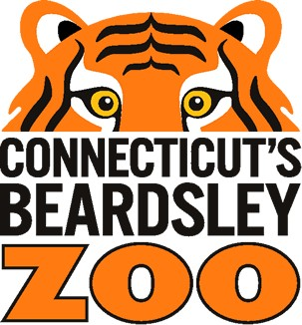
Connecticut's Beardsley Zoo is closer than you think and open daily from 9:00 am to 4:00 pm.

THE MARITIME AQUARIUM AT NORWALK, 10 N. Water Street, Norwalk, CT; (203) 852-0700, www.MaritimeAquarium.org. Hours: 10 a.m. to 5 p.m. daily.. IMAX® theater offers the largest movie screen in Connecticut. The name of the Aquarium's new research vessel will be R/V Spirit of the Sound – chosen through a recent Name the Boat contest open to Norwalk school students

For more information about The Maritime Aquarium’s educational programs, or its exhibits and IMAX movies, go to www.maritimeaquarium.org or call (203) 852-0700.

What Is Science Matters? Science Matters is an initiative by the National Science Teachers Association (NSTA) to bring content, news, and information that supports quality science education to parents and teachers nationwide. Science Matters builds on the success of the Building a Presence for Science program, first launched in 1997 as an e-networking initiative to assist teachers of science with professional development opportunities. Building a Presence for Science—now Science Matters—reaches readers in 34 states and the District of Columbia. Why does Science Matter? Science is critical to understanding the world around us. Most Americans feel that they received a good education and that their children will as well. Unfortunately, not many are aware that international tests show that American students are simply not performing well in science when compared to students in other countries. Many students (and their parents!) believe that science is irrelevant to their lives. Innovation leads to new products and processes that sustain our economy, and this innovation depends on a solid knowledge base in science, math, and engineering. All jobs of the future will require a basic understanding of math and science. The most recent ten year employment projections by the U.S. Labor Department show that of the 20 fastest growing occupations projected for 2014, 15 of them require significant mathematics or science preparation to successfully compete for a job. This is why Science Matters. Quality learning experiences in the sciences—starting at an early age—are critical to science literacy and our future workforce. Feel free to publish this information in school newsletters and bulletins, and share it with other parents, teachers, and administrators.

