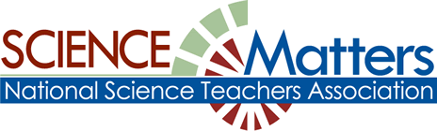

CONNECTICUT SCIENCE CONNECTION
September 2018
The Connecticut Building a Presence for Science Network is sustained through the advocacy of the CCAT, Connecticut Science Supervisors Association, the Connecticut Science Teachers Association, and the Connecticut Academy of Science and engineering

State Coordinator.David Lopath lopath@comcast.net , List Moderator..Eloise Farmer eloisef302@gmail.com

Names and e-mail addresses of our Points of Contact and Key Leaders are not shared with any other entitY

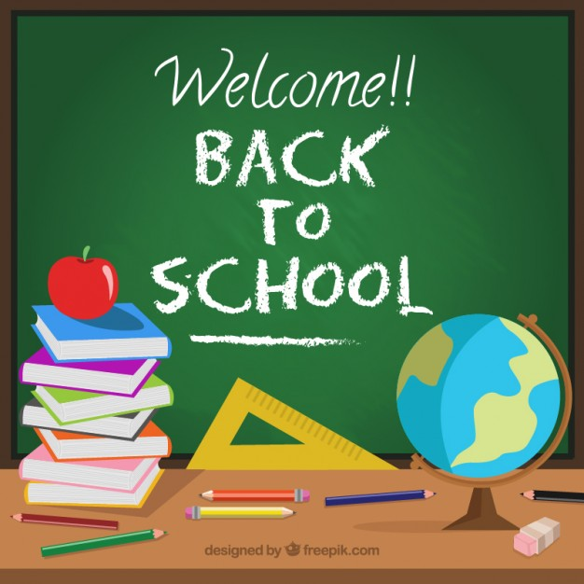
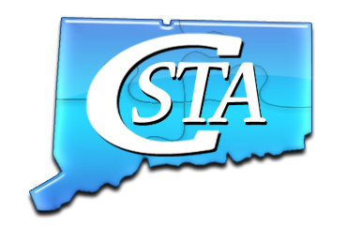
Professional Development Opportunities! Are you interested in high quality, low cost, Teacher Professional Development opportunities? Visit the CSTA website and click on Opportunities. You will not be disappointed. Contact us if you have questions.
Click on the link to learn more about JPSS!

https://scijinks.gov/subscribe/
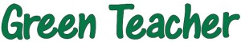Green Teacher has recently launched a YouTube Channel. In time, we hope this will grow into a valuable resource for educators.
https://greenteacher.com/check-out-these-videos/

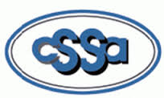
Join the CSSA
******************************Connecticut Science Teachers Association Sponsored Events
more information and registration links at https://www.csta-us.org/events
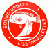
The Sheffield Island and The Estuary
Ecosystems of Long Island Sound
Come learn about the Sheffield Island Lighthouse, the
Steward B. McKinney National Wildlife Refuge and how
to take your students on an interdisciplinary field trip that
incorporates NGSS, History and Science into an
unforgettable interdisciplinary and educational experience
for all grade levels.
Date: September 15, 2018 - 9 am - 3 pm
Join us on the Norwalk Seaport Associations ferry cruise to Sheffield Island. Learn
about the Maritime history of Norwalk’s Harbor and make curricular connections with Next Generation Science
Standards such as
HS LS2-6 , DCI LS2.A - Interdependent Relationships, DCI LS2. C - Ecosystem Dynamics, DCI LS4.D -
Biodiversity and Humans and CCC Stability and Change, Systems and System Models
● View and identify a wide variety of bird species on the journey to the island.
● Discuss the adaptations that have allowed various species to thrive in Norwalk’s Harbor.
● Tour of the lighthouse and learn about the history of the island and the lighthouse keepers
● Explore the coast line and view, sketch or collect and identify a wide variety of
○ Shells, Crabs, Seaweeds and other small organisms
● Take water samples and discuss water quality
● Investigate, explore and compare the variety of estuary ecosystems present on the island
including the salt marsh, rocky shore and sandy shore.
● Discuss the importance of each ecosystem and the impact humans have on those systems
● See one of the largest Osprey nests atop the boat ramp to the island
● Pull a plankton net and observe and identify plankton species present
● Pull a seine net and observe and identify the species collected
● Do a crab count of local crabs by size, species and sex.
Workshop Cost and Registration
1. Complete the google form using the link below to register :
https://goo.gl/forms/gzhrVFPeXnvxuXH03
2. Cost: $10 venmo or check - details will be sent once registration is completed. Payment must be made
to reserve your spot for the workshop
3. Goodie bags with supplies to run your own field trip will be given out at the end of the class and may include, seines, nets and other fun stuff.
Please dress for the weather and be prepared to get wet, muddy and have fun. Bring your own lunch, bug spray and sunscreen we will be outdoors on an island for the majority of the day. Class will be taught by:
Eva Bartush
Brien McMahon High School’s
Marine Biology Teacher
Kimberly Smith
AITE High School’s
Marine Biology Teacher

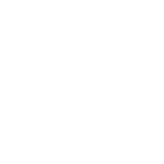
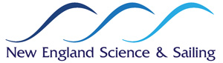
Think FALL for field trips!

Looking for your next field trip? Students LOVE to come learn at NESS. Get them out on the water kayaking, sailing and tidepooling! We're filling dates now for FALL...email Pam Gibbs at pgibbs@nessf.org.…………………………

Register for the American Museum of Natural History's Seminars on Science Courses.
Are you an educator looking to advance your career and earn graduate credit? Sign up for our six-week online courses in the life, Earth, and physical sciences. Taught by Museum scientists and classroom educators, Seminars on Science courses are accessible anytime, anywhere. Get access to cutting-edge research, rich science content, and powerful classroom resources.
Click here to learn more.
Fall Session 1:
September 17 – October 28
Registration deadline: September 3
Check out the new Seminars on Science video to learn more about the courses. Hear from course authors, curators, learners, and instructors as they share their experiences with these online courses. AMNH is offering 15% off course fees to NSTA members. Use code NSTA2018 upon checkout.

Want to Enhance Your Knowledge of the Next Generation Science Standards? Enroll in our Shifting to the NGSS: Professional Book Study in October 2018! This four-week online book study will help you move towards classroom implementation with insightful webinars, discussions, and resources. During the online book study, you'll participate in four webinars and moderated discussions with six hours of live exchange with experts and other educators. All of this learning occurs from the convenience of your own home or office without the hassle of conference travel. The accompanying e-book offers a comprehensive introduction to the Next Generation Science Standards. All told, the e-book offers up to 40 hours of interactive professional learning and covers background information, each of the three dimensions in depth, and steps to move teachers toward classroom implementation. By the end of the book study, you'll be able to:
- Communicate an understanding of the three-dimensions and 3D learning
- Begin to design NGSS lessons that work coherently within a storyline or unit of study
- Identify phenomena that can drive student learning

Ensure the success of your Fall by registering for this online book study.
Please contact Flavio Mendez via e-mail or by phone at 703-312-9250 for a quote.
////////////////////////////////////////////////////////////////////////////
MARK YOUR CALENDARS FOR NSTA'S 2018 FALL CONFERENCES
October 11-13, 2018, Reno, Nevada, Reno-Sparks Convention Center

November 15-17, 2018, National Harbor, Maryland, Gaylord National Resort & Convention Center

November 29-Dec. 1, 2018, Charlotte Convention Center, Charlotte, North Carolina
………………………………………………………………………………………………………………………….
MORE PD for 2018: Check the link below:
The link is as follows: https://ctsciencecenter.org/education/mandell/ngsx-info/
………………………………………………………………………………………………………………………….
TEACH CLIMATE SCIENCE IS AN INITIATIVE OF THE PALEONTOLOGICAL RESEARCH INSTITUTION (PRI, ITHACA NY, www.priweb.org ).
In response to cuts in federal funding for climate science research and education, removal of scientists from federal environmental panels and agencies, and widespread dissemination of climate science denial propaganda, PRI has embarked on a campaign to distribute The Teacher-Friendly Guide™ to Climate Change to every public high school science teacher in the country.
The Teacher-Friendly Guide™ to Climate Change is the tenth book in PRI’s Teacher-Friendly Guide series (www.teacherfriendlyguide.org). Following the Heartland Institute’s national mailing of “Why Scientists Disagree about Global Warming,” PRI decided to step up and counter the dissemination of disinformation by providing teachers with access to peer-reviewed climate science and vetted strategies on teaching a potentially controversial topic. While all of the Teacher-Friendly Guides are available as free pdf downloads, PRI has embarked on a crowdfunding campaign in order to reach out to teachers and send each one their own copy of the climate change guide.
We are reaching out for help with both dissemination and fundraising. Buying the book supports both of these efforts. You can order the book and download the free pdf at http://priweb.org/tfgcc. While the book was written with teachers in mind, it's friendly to any reader.
As of summer 2018 50,000 teachers in 36 states will receive copies of The Teacher-Friendly Guide™ to Climate Change. You can help PRI achieve the goal of reaching 200,000 teachers. We are striving to identify a point person in each school who will be the addressee for the package, and help to insure that the books actually reach teachers. Sign up to be a point person here: http://bit.ly/TFGCCcontact.
Reach out to friends and social media networks to support the crowdfunding campaign (http://bit.ly/TeachClimateScience) and to get the word out about the Teach Climate Science Project.
………………………………………………………
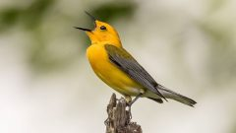
The Cornell Lab of Ornithology’s free webinar series launches soon! These engaging monthly webinars provide background information and K-12 activities related to scientific observations, inquiry, NGSS, citizen science, and outdoor learning. Educators can also opt to receive one Continuing Education Unit (CEU) from Cornell University. Learn more and register at:
http://www.birdsleuth.org/free-webinars/. Feel free to reach out if you have any questions
SAVE THE DATE! Connecticut Invasive Plant Working Group’s (CIPWG) Symposium:
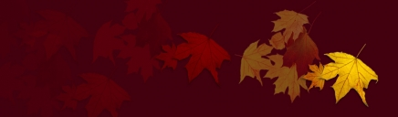
The symposium will be held at the UConn Storrs campus on Thursday, October 4, 2018 from 8:00 a.m. until 4:30 p.m. The theme of the symposium is "Invasive Plants in Uncertain Times: Achieving More with Less". Keynote speaker, Judy Preston, Long Island Sound Outreach Coordinator with the Connecticut Sea Grant, will present, “Raising the Bar on Sustainability: Restoration for Property Owners and Maximizing Plant Functionality.”

Concurrent afternoon sessions will include:
· Introduction to Invasive Plant Management - Panel discussion with various experts.
· The Nursery Industry and Non-Invasive Alternatives – Panel discussion on the role of nurseries
· Early Detection and Invasive Plant Risk Assessment – How to address newly introduced plants
· Advanced Invasive Plant Management – Cost/benefit analysis of management options
· Innovative Invasive Plant Technologies – New technologies to report and learn about invasives
· Native Alternatives and Pollinators – Planning your native plant garden

Research and management posters, an invasive plant identification area, and other educational exhibits will be featured throughout the day.
Program and other materials, including online registration information, are available on the CIPWG website at https://cipwg.uconn.edu/2018-symposium/.
………………………………………………………………………………………………………………………………….
PHENOMENA, Anyone? Looking for meaningful phenomena based instruction? Then check out this amazing opportunity that happens right in your own home.
http://learningcenter.nsta.org/products/online_courses/vc_180728.aspx

Teachers In Space, Inc.
www.teachers-in-space.com
Flight Experiments Program 2018-2019
Teachers! Would you and your students like to send a science payload to the edge of space? Teachers in Space’s Flight Experiments program brings spaceflight to your classroom via biweekly live video conferences with our experts, teaching you to design, build and fly real flight experiments with your students.
2018-19 Flight Experiments Program is offered in 5 phases. You may register and pay for each new phase as you complete the preceding phase (total cost including equipment and flights: $6200) or save $200 by registering up front for the whole program for just $6000. Progress is competitive: Teams must successfully complete the deliverable for each phase to be eligible for the next phase, and only the top 75% teams in each phase will proceed. If your team is eliminated at any phase, you may apply your unused phase fees to the next year’s program, or receive a refund of 50% cost of unused phases. Your experiments are yours to keep.
Registration for Phase 1 (required) runs 9-23 October 2018 (limit 100 teams) and costs $200 per team. Register at http://teachers-in-space.com/flightex/
Registrants receive a TIS CubeFrame, an hour of lecture and questions with TIS Board member and retired NASA Deputy Director of Technology Jim Adams, 4 hours live video training on Flight Experiments and 2 hours telephone support time. Topics: What can we study? How can we study it? Flights available to TIS teams; popular areas of inquiry; recently flown experiments; choosing a testable question and designing a practical experiment. Deliverable due 27 November: Proposal Topic for a Flight Experiment.
Teachers in Space (TIS) has an extensive record of successfully flying student experiments to space and the near space environment. Since 2012 we have annually flown and recovered experiments reaching the Stratosphere (a Mars analog) using high altitude balloons and the world-record-setting Perlan 2 glider. TIS have also sent two classroom experiments to the International Space Station and have participated for four years in testing a commercial spacesuit on parabolic microgravity flights. SPECIAL PRIZE: One team completing our entire 5 phase program will get to send one member of their community (pending flight readiness approval) aboard a parabolic microgravity flight in the fall of 2019! James W. Kuhl, Vice President, Teachers in Space, ………………………………………….
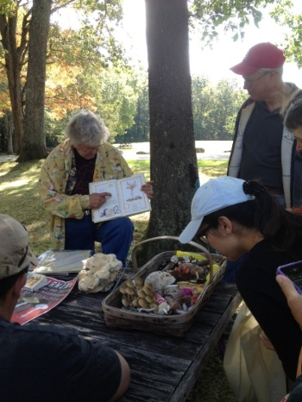
Session proposals for the 8th annual STEM forum and expo in San Francisco, are now being accepted. The dates are July 24-26 2019. The area conferences will be held in Salt Lake City October 24-26 2019, Cincinnati November 14-16 2019, and Seattle, December 12-13 2019. To submit a proposal, visit www.nsta.org/conferenceproposals

On October 24, NSTA will hold a free Web Seminar on Developing a Competititve Teacher Award Application. The session runs from 6:30 to 8PM ET. To register, go to http://goo.gl/PRmPR2 .

LOVE THE SEA TURTLES? Want to help in their conservation? Join the SEE Turtles Costa Rica Leatherback Turtle Volunteer trip. You will help collect eggs and move them to hatcheries, and work with the baby turtles once they hatch. The trip is June 9-15 2019. Individuals and groups up to 12 can apply. Visit https://www.seeturtles.org/costa-rica-leatherback-turtle-volunteer-trip for more info.

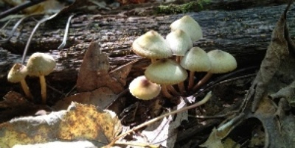
Mysterious Mushrooms
Connie Borodenko, Connecticut Valley Mycological Society
Saturday, September 8, 10 am to 11:30 am – eastern, CT
Advance registration required: $20
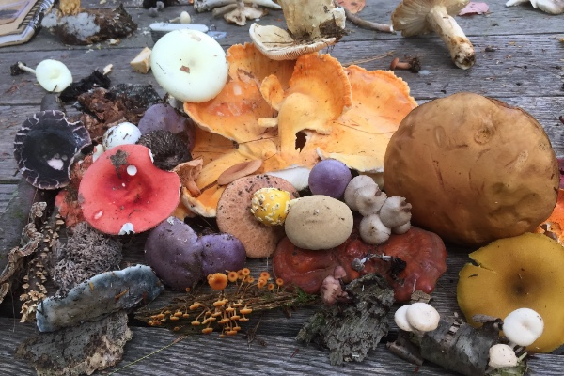
Discover the startling, colorful, sometimes delicious, and sometimes deadly, world of mushrooms and fungi with mycologist Connie Borodenko. Mushrooms are fungi usually found growing on soil or decaying matter. The mushroom is the fruiting body of mycelium, which is usually hidden underground or throughout the host that it is growing on. Participants will seek out edible mushrooms such as the sweet Chanterelles, spicy trumpets, slippery honeys and, Hen of the Woods. Identifying dangerous and nonedible mushrooms such as the deadly Destroying Angel and Death Cap will also be explored.
Bring a basket and paper bags for gathering these denizens of the shadows during the first part of the program. Then learn about the fascinating world of fungi, collection techniques, and important safety considerations as we discuss the findings with our mushroom expert. This hike may be challenging for some and will include hilly areas.
The program fee is $20 and advance registration is required. This program is for adults and children ages 8 and above. Children must be accompanied by an adult. For registration information visit http:///www.cac.uconn.edu/mnhcurrentcalendar.html or call 860-486-4460.

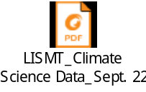 /click on the LISMT for a great workshop! You must be in Word for this to work…I cannot convert from their PDF file directly.

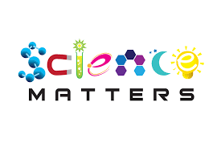
What Is Science Matters? Science Matters is an initiative by the National Science Teachers Association (NSTA) to bring content, news, and information that supports quality science education to parents and teachers nationwide. Science Matters builds on the success of the Building a Presence for Science program, first launched in 1997 as an e-networking initiative to assist teachers of science with professional development opportunities. Building a Presence for Science—now Science Matters—reaches readers in 34 states and the District of Columbia. Why does Science Matter? Science is critical to understanding the world around us. Most Americans feel that they received a good education and that their children will as well. Unfortunately, not many are aware that international tests show that American students are simply not performing well in science when compared to students in other countries. Many students (and their parents!) believe that science is irrelevant to their lives. Innovation leads to new products and processes that sustain our economy, and this innovation depends on a solid knowledge base in science, math, and engineering. All jobs of the future will require a basic understanding of math and science. The most recent ten year employment projections by the U.S. Labor Department show that of the 20 fastest growing occupations projected for 2014, 15 of them require significant mathematics or science preparation to successfully compete for a job. This is why Science Matters. Quality learning experiences in the sciences—starting at an early age—are critical to science literacy and our future workforce. Feel free to publish this information in school newsletters and bulletins, and share it with other parents, teachers, and administrators.

