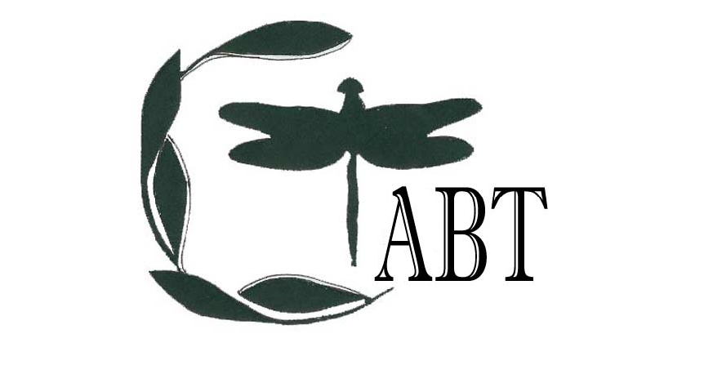

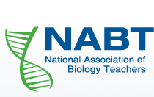

**April 6, 2019**

**STEM CONFERENCE**

# COPERNICUS HALL

CENTRAL CONNECTICUT STATE UNIVERSITY  
NEW BRITAIN

**REGISTER online at https://tinyurl.com/CTABT2019**

**CTABT**

**Membership Form**

The Connecticut Association of Biology Teachers (CTABT) is an affiliate of the National Association of Biology Teachers (NABT). Check our website for more information and to learn about past, present, and future events at [www.ccsu.edu/CTABT](http://www.ccsu.edu/CTABT). Send your name and contact information along with your membership fee (CTABT membership $20.00/ Student membership $10.00) to:

Eileen F. Roark, CTABT Treasurer

Central Connecticut State University

Dept. of Biology, NC332

New Britain, CT 06050

**Make checks payable to “CTABT**”

Name:

Email address: ______________________________

Work place: __________________

**Are you interested in presenting a workshop or have ideas for an event? Please let us know!**

# Noon-1:00 PM KEYNOTE: MASTERING BIOLOGY, Pearson

1:00-1:15 **BREAK**

1:15-2:15 PM **WORKSHOP SESSION 2**

**2A** TOWARDS UNDERSTANDING ‘HOT’ SEEDS: A THIN-LAYER CHROMATOGRAPHIC SEPARATION OF CAPSAICINOIDS FROM FOODS Sourav Chakraborthy, Ph.D. CCSU

**2B**  GENES IN SPACE STEM CONTEST: YOUR DNA EXPERIMENT IN SPACE

# Engage your students in designing DNA experiments for the International Space Station. Students participate in self-guided experimental design at the cutting edge of space biology. Winning experiments are done in space! We offer free lesson plans, educational videos, and biotechnology loans! Inspire your students to pioneer real science in space. Sebastian Kraves, Ph.D. Mini PCR

**2C** ENCOURAGING STUDENT ENGAGEMENT THROUGH CITIZEN SCIENCE

Student engagement can be challenging on any grade level. Maintain students’ excitement through real data collection and analysis in the classroom that will benefit scientists from around the globe. Learn the importance, strategies and assessment of hands on citizen science exercises that can be adapted for a variety of classroom settings. Examples include: Wildcam Gorongosa, EteRNA, and Zooniverse. Gemma B. Bartha, Springfield College

2:15-2:30 PM **BREAK**

2:30-3:30 PM **KEYNOTE**: TEACHING IN THE ANTHROPOCENE

Gary Gomby, Ph.D., CCSU

3:30-4:00 PM **CLOSING CEREMONIES**

**AGENDA**

8:30 – 9:00 AM **REGISTATION**

9:00 – 10:15 AM **OPENING CEREMONIES**

**KEYNOTE:** BIOPHYSICS BETWEEN THE LINES: HOW TO COMBINE DIFFERENT DISCIPLINES TO SOLVE COMMON PROBLEMS Yadilette Rivera-Colon, Ph.D., Bay Path University

10:15 – 10:30 AM **BREAK**

10:30 – 11: 30 AM **WORKSHOP SESSION 1**

**1A** WORKING WITH PERIPHYTON AND IDENTIFYING DIATOMS TO ASSESS WATER QUALITY

Participants will look at periphyton collected from streams near the school. They will learn how to clean the periphyton and collect diatoms to identify and assess water quality using bio-metrics. Alberto Mimo, CCSU

**1B** THE OPIOID EPIDEMIC: EXPLORING THE GENETIC ASSOCIATIONS OF OPIOID ABUSE AND TREATMENT

Opioid abuse is prevalent in the U.S. Students take on the role of researchers as they design an experiment utilizing a fast electrophoresis protocol of pre-amplified DNA samples that predicts addiction risks for opioid dependence, treatment, and implications to precision medicine based on a patient's genotype. Tamica Stubbs, Bio-Rad

**1C** EXPLORE THE PHENOMENON OF FISH KILL IN CONNECTICUT

Attendees will develop models and explore classroom activities to gather information to explain the phenomenon of fish kills in CT. Marsha Bednarski, Ph.D. CCSU

11:30- Noon **LUNCH**