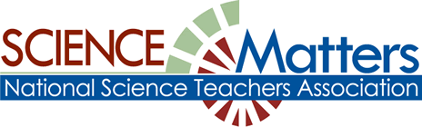

CONNECTICUT SCIENCE CONNECTION
December 2018
The Connecticut Building a Presence for Science Network is sustained through the advocacy of the CCAT, Connecticut Science Supervisors Association, the Connecticut Science Teachers Association, and the Connecticut Academy of Science and engineering

State Coordinator.David Lopath lopath@comcast.net , List Moderator..Eloise Farmer eloisef302@gmail.com

Names and e-mail addresses of our Points of Contact and Key Leaders are not shared with any other entitY

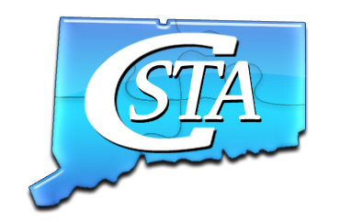
Professional Development Opportunities! Are you interested in high quality, low cost, Teacher Professional Development opportunities? Visit the CSTA website and click on Opportunities. You will not be disappointed. Contact us if you have questions.
Click on the link to learn more about JPSS!

https://scijinks.gov/subscribe/ 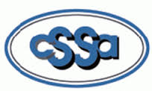Join the CSSA Thanks to member Sarah Faulkner! Mars news keeps getting better. It turns out that that amazing parachute was made here in CT at Pioneering Aerospace in South Windsor!!! Here are some resources for those of you who may be interested: Info on Pioneer: https://www.nbcconnecticut.com/…/South-Windsor-Company-Desi…
Here's info from NASA on the design process for making the parachute, plus the material and consideration of forces on the chute: https://mars.nasa.gov/…/missi…/spacecraft_edl_parachute.html and finally, here is a terrific video on the testing of the parachute:https://www.nasa.gov/…/third-aspire-test-confirms-mars-2020…

Fun!
JASON PROFESSIONAL DEVELOPMENT
New! World of Waves – FREE 2-Part Workshops - Sign-up Soon – Space is Limited.
Best for Grades 4, 6-8, 9-12
Sponsored through the Office of Naval Research and the Savings Bank of Manchester. After attending, participants have an option to receive a BOSEBuild Speaker Cube Kit of their own to pilot selected activities to explore: how sound works; how speakers work; frequency and waveforms. REGISTER at: www.jason.org/ct

EASTCONN – Hampton, CT 9:00am – 3:30pm
Part 1: Wednesday, January 16, 2019 (snow date 1/23/2019) Part 2: Tuesday, March 12 2019

Watch the World of Waves promo video here: https://www.youtube.com/watch?v=R4uq8T7y5Is
Build a deep, working understanding of the physics of waves and their importance in our world. Meet STEM role models ranging from Navy officers to robotics engineers & rock musicians that apply the physics of waves in their work.
Free One Hour Webinar – JASON for Elementary – November 14, 2018 – 3:30pm Learn what NGSS resources are available and how to navigate the JASON site. With a live trainer and will include Q-and-A to help folks with specific questions. Register at www.jason.org/ct.

JASON Learning Resources - Free for all CT Public Schools – Supplement or Build Your NGSS Units!
If you haven't renewed / reactivated your account, you can simply login and you will be prompted to update your school information. If you have forgotten your login information - no problem - just go to the login page: https://login.jason.org/gated/login and use the "forgot username or password?" link.

RECYCLE TO REBUILD Contest! Calling all artists, filmmakers, and recyclers in grades K–12! A national recycling awareness contest sponsored by the Institute of Scrap Recycling Industries (ISRI) and JASON Learning. Learn more at: https://www.jason.org/recycling-contest
One of the most important human-made resources we have is our infrastructure: the roads and bridges we drive on, the airports, water ways and train lines we travel through, and the cellular towers, cables and fiber optic networks that connect us. Many important parts of our infrastructure are beginning to show signs of wear-and-tear. Join the challenge to imagine innovative ways to use RECYCLED materials to support the rebuilding of our infrastructure! Submission deadline December 15, 2018. Contact amy@jason.org with questions.

A GRANT PROJECT OFFERING from the Connecticut Orthinological Society: COA Mini-Grant applications is January 15, 2019. Our Mini-Grant program gives preference to projects directly benefiting Connecticut's birds. All the information and application forms are available on our website at this link: https://www.ctbirding.org/resources/coa-mini-grant/

Identify phenomena that can drive student learning
PHENOMENA, Anyone? Looking for meaningful phenomena based instruction? Then check out this amazing opportunity that happens right in your own home.
http://learningcenter.nsta.org/products/online_courses/vc_180728.aspx

Session proposals for the 8th annual STEM forum and expo in San Francisco, are now being accepted. The dates are July 24-26 2019. The area conferences will be held in Salt Lake City October 24-26 2019, Cincinnati November 14-16 2019, and Seattle, December 12-13 2019. To submit a proposal, visit https://www.nsta.org/conferences/sessions/meetingsacceptingabstracts.aspx

BIOS Six-Day Educator Training Workshop in Bermuda! 12 participants will learn how to plan and execute field study courses for their students. Explore attractions to learn how to incorporate them in education experiences. Preservice and inservice middle and high school educators my apply by May 1. For more information, go to http://www.bios.edu/education/educator-workshops-at-bios/

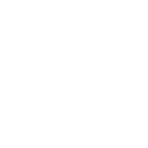

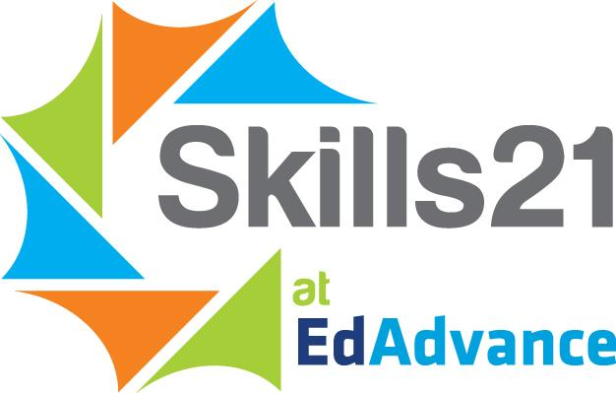
Skills21 at EdAdvance is excited to announce an opportunity for teachers interested in the intersection between Science and Computer Science. With support from a new National Science Foundation grant, Skills21 is recruiting a cohort of teachers this year who want to engage their class in a CS challenge and present student team solutions at the 2019 Expo Fest on June 1, 2019 (expofest.skills21.org).
Through the new Skills21 Science/CS challenge, student teams are compelled to develop a computer science product, service or solution leveraging a scientific discipline to meet a need, solve a problem or capture an opportunity. Student solutions might include mobile apps, wearable solutions or other innovative uses of computer science.
Participating teachers will receive:
- $1000 stipend for planning, out-of-class time engagement and curricular review
- $500 for project materials
- Onsite coaching and professional development
Participating teachers will need to:
- Pilot and/or provide feedback on Computer Science infused Science units including lesson plans and an end of unit performance assessment
- Bring a team of students to the 2019 Expo Fest to compete in the new Science/CS Challenge
- Allow Skills21 to conduct pre- and post-intervention surveys (September and June)
What’s the time commitment?
- In and out of class time commitments for teachers will vary based on individual class settings. Experienced Skills21 staff will work with prospective teachers to help gauge the required time commitment and investment
Priority Eligibility:
- First priority in the early stages of this grant are for teachers that work with traditionally underserved student populations
How to Get Involved
Interested teachers should contact Liz Radday (radday@edadvance.org) or Susan Auchincloss (auchincloss@edadvance.org).

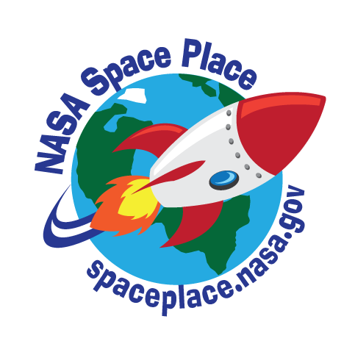

Elementary Science opportunities.
DEEP Climate Change Workshops and Opportunities
Webinars on the first Wednesdays of the month at 4:00 pm include the following topics: December- Understanding Environmental Footprints
January- Water Quality and Chemistry
February- What Color is your Air- Ozone, EPA Flag Program
Workshops planned to date:
February 27- Environmental Literacy K-12 For more information go to the DEEP webpage at the following URL:
https://www.ct.gov/deep/cwp/view.asp?a=2691&q=322502&depNav_GID=1627

The following are resources from Nsta Reports. One of the advantages of being an Nsta member means you have access to this kind of information for your use:

Thanks to Rebecca Newburn of Oakland, CA, Interactive science notebook resources: adaptable for use with middle and high school students, wih pages that highlight crosscutting concepts and science and engineering practices. There are rubrics, graphic organizers, and other worksheets to help students learn to collaborage and communicate their ideas using scientific evience and reasoning. To get this resource, got to https://goo.gl/Qq1WFT

Based on the Ruff Ruffman Show, this app helps students in grades pre-k-2 to discover the “stuff” their world is made of. Students use the app to investigate their surroundings by taking pictures of different materials, textures, and patterns, as they learn science vocabulary. They are sent to hunt for items with specific properties. Find the app at: https://goo.gl/ckaqGy

NJCTL Phenomena-based courses for Middle Level: the New Jersey center for teaching and Learning has posted complete materials for its Physical Environment, Living environment and Mathematical Physics courses. Designed for grades 6-8 supporting the NGSS, each unit is structure around a different set of phenomena
and features several chapters and accompanying resources. Https://goo.gl/b7Ho1v

A game about energy choices from the US environmental Protection agency: Generate is an interactive board game for middle and high school levels, intended to teach students about the complex relationship between energy choices and environmental quality. Costs and benefits of choices we make are illustrated with their effects on climate, air , water, and overall environmental quality. Teachers can download a printable version including an introductory presentation, game board and pieces score sheet, and instructors guide. Teachers can access a seminar presentation on the game that discusses energy issues. Https://goo.gl/an7QJM

Glenn Engineering Design Challenges: Sponsored by NASA, students in grades 5-12 are challenged to design the next generation of aeronautics and space vehicles, habitats, and technology. Each unit presents a challenge based on current research and provides opportunities for students to work in science teams. Each unit includes an introductory video a facilitation guide and presentation, information about how the unit content supports NGSS, and links to related NASA resources. Click on https://goo.gl/YHhGgS

RECOGNIZING POISONOUS PLANTS: Photographs and information about the location and identification of poisonous plants help students protect themselves before and after exposure. https://goo.gl/xqJRrT

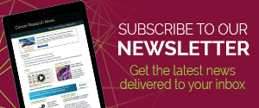The FunScienceNetwork…What is it?

- FunScienceDemos - A YouTube channel with over 150 science demonstrations by master teachers. Every important science ideas kids should know before high school. Over 50,000 subscribers so far! https://www.youtube.com/user/funsciencedemos
- FunScienceSupport - A website filled with free teacher resources for K-8 science education. Readings, writing prompts, math activities, poems and more! https://sites.google.com/temple.edu/funscience/home
- FunScienceToons - UNDER CONSTRUCTION - Science animation in which siblings help each other learn about science and the natural world. Watch our first animation. Earth Spins and the Day Begins
- LearningScience.org - A dynamic and curated list of free, high quality, online resources from around the world for science education. http://new.learningscience.org/wp/

Grades 6–12

Generate: The Game of Energy Choices
This interactive board game teaches students about the costs and benefits of the energy choices we make; what happens if the mix of energy sources changes in the future; and what energy choices mean for our climate, air, water, and overall environmental quality. Teachers can download a printable version of the game and accompanying materials.

STUDENT LOAN NOTICE!!

Have a student loan that needs forgiveness? Go to http://bap.nsta.org/Attachments/PblcFrgvnss-TeacherTitle.pdf

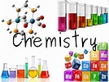
Realism Virtual Chemistry Labs: Virtual 3-D Chem simulations for Middle and High School levels that support the NGSS. Gas-forming reactions, thermochemistry, exothermic reactions, acid-base information, and chemical reactions. Can be found at:
https://realism.io

Emerging Female Scientist (EFS) is the first electronic, peer-reviewed, open access scientific journal promoting and publishing articles by female middle and high school students. The goal is to inspire, recognize, train, and equip students to pursue and share their scientific ideas and research. All research submissions must have a female as the primary author. Every submission is received and reviewed by an all-female, renowned editorial board, which is guided by a Scientific Advisory Board of nationally-recognized scientists, researchers, and educators.

The editorial and advisory boards are committed to fostering a fun and meaningful research and publication experience. Submissions will receive constructive feedback on the content, research methods, results, and conclusions. This experience teaches students about the publication process from peers and experts who ultimately help them refine and improve their work into a polished and worthy final research product. In addition to original research, students can also submit interviews with female STEM leaders, historical vignettes of noted female scientists, and/or current science and technology review articles.

NSTA is well known for its commitment to furthering science education and fostering STEM activities nationwide, as well as working with Key Leaders in each state to develop the Science Matters program. Can you bring this announcement to the attention of Key Leaders and STEM Coordinators in your state who may find the journal a useful educational opportunity for aspiring science students? Additionally, my editorial staff would welcome input on the journal and how it can best meet the goal of increasing the number of young women who choose science as their career path.

Please visit our new website: www.emergingfemalescientists.com

Student Essay Contest Now Open!

“I was offering time and laughs—the men and women fighting the war were offering up their lives,” said Bob Hope of his experiences entertaining troops during World War II. “They taught me what sacrifice was all about.”
In celebration of the special exhibit So Ready for Laughter: The Legacy of Bob Hope, The National WWII Museum is focusing its 2018 Student Essay Contest on the duty of art and artists during times of war and conflict. The contest, which asks entrants to consider the above quote by Hope in the context of the overall theme of the wartime role of entertainers and artists, is open to middle school (grades 5–8) and high school (grades 9–12) students. For more information on the essay contest, please visit The National WWII Museum 2018 Student Essay Contest website.

The Billy Michal Student Leadership Award

The National WWII Museum is currently taking nominations for The Billy Michal Student Leadership Award, given annually to one student from each state and the District of Columbia who demonstrates the values of leadership, teamwork, tolerance, creativity, and perseverance in their community. For more information and to nominate a student, see The Billy Michal Student Leadership Award website.

CSSS] NSTA Position Statement on Teaching Climate Science.
Want to make sure that you’ve all seen NSTA’s latest position paper! Below is the press release issued and a link to the Statement.
TEACH CLIMATE SCIENCE IS AN INITIATIVE OF THE PALEONTOLOGICAL RESEARCH INSTITUTION (PRI, ITHACA NY, www.priweb.org ).
In response to cuts in federal funding for climate science research and education, removal of scientists from federal environmental panels and agencies, and widespread dissemination of climate science denial propaganda, PRI has embarked on a campaign to distribute The Teacher-Friendly Guide™ to Climate Change to every public high school science teacher in the country.
The Teacher-Friendly Guide™ to Climate Change is the tenth book in PRI’s Teacher-Friendly Guide series (www.teacherfriendlyguide.org). Following the Heartland Institute’s national mailing of “Why Scientists Disagree about Global Warming,” PRI decided to step up and counter the dissemination of disinformation by providing teachers with access to peer-reviewed climate science and vetted strategies on teaching a potentially controversial topic. While all of the Teacher-Friendly Guides are available as free pdf downloads, PRI has embarked on a crowdfunding campaign in order to reach out to teachers and send each one their own copy of the climate change guide.
We are reaching out for help with both dissemination and fundraising. Buying the book supports both of these efforts. You can order the book and download the free pdf at http://priweb.org/tfgcc. While the book was written with teachers in mind, it's friendly to any reader.
As of summer 2018 50,000 teachers in 36 states will receive copies of The Teacher-Friendly Guide™ to Climate Change. You can help PRI achieve the goal of reaching 200,000 teachers. We are striving to identify a point person in each school who will be the addressee for the package, and help to insure that the books actually reach teachers. Sign up to be a point person here: http://bit.ly/TFGCCcontact.
Reach out to friends and social media networks to support the crowdfunding campaign (http://bit.ly/TeachClimateScience) and to get the word out about the Teach Climate Science Project.

Subject: $1250 Scholarships for Amazon Rainforest PD Workshop

Educator Academy in the Amazon Rainforest
The July 1-11, 2019 Educator Academy in the Amazon Rainforest of Peru is a cross-curricular professional development workshop for K-12 formal and informal educators to learn and use:
- 21st Century Instruction: Inquiry-Based Exploration ~ NGSS ~ STEM ~ 5E
- Inquiry Protocols & Resources: Project Learning Tree ~ Cornell Lab of Ornithology ~ & More!
- Global and Cultural Perspectives: ~ Sustainability ~ Global Education ~ Indigenous Cultures

Join Al Stenstrup, Project Learning Tree; Dr. Nancy Trautmann, Cornell Lab of Ornithology; Kristie Reddick, The Bug Chicks; along with scientists Dr. Steve Madigosky, Widener University; and Randy Morgan, Curator/Entomologist, Cincinnati Zoo as you:
- Work side-by-side with scientists and researchers on citizen science projects and field studies on the ACTSPeru Rainforest Canopy Walkway in one of the world’s most biologically diverse environments.
- Explore conservation and sustainability via hands-on workshops with indigenous communities.
- Spend a day in an Amazon village and explore the role of education in creating a sustainable future for Amazon children.
- Work in grade-level cohorts to develop strategies for using the Amazon as a vehicle for incorporating standards-based inquiry, STEM, and sustainability education into your classroom.

PLT Certification, BirdSleuth, and other resources included. Academic Credit and Machu Picchu Extension optional. $1250 scholarship deadline February 1, 2019. With a scholarship, Academy Program fees are $1345 (airfare not included). Space is limited to 30 educators - Register early to secure your spot!

Get the details and download a syllabus and scholarship application at: www.amazonworkshops.com/educator-academy. Contact Educator Academy Director, Christa Dillabaugh, for more information:

LOVE THE SEA TURTLES? Want to help in their conservation? Join the SEE Turtles Costa Rica Leatherback Turtle Volunteer trip. You will help collect eggs and move them to hatcheries, and work with the baby turtles once they hatch. The trip is June 9-15 2019. Individuals and groups up to 12 can apply. Visit https://www.seeturtles.org/costa-rica-leatherback-turtle-volunteer-trip for more info.
* Cornell Lab of Ornithology’s free webinar series launches soon! These engaging monthly webinars provide background information and K-12 activities related to scientific observations, inquiry, NGSS, citizen science, and outdoor learning. Educators can also opt to receive one Continuing Education Unit (CEU) from Cornell University. Learn more and register at:
http://www.birdsleuth.org/free-webinars/. Feel free to reach out if you have any questions

IN case you missed this, a great depiction of the Talcott Mountain Science Center that appeared on CPTV! https://cptv.org/at-wonders-peak/

A Holistic Way of Looking at Education
In contrast to the way students traditionally learned, where teachers were the "custodians of knowledge," now technology enables students to get knowledge and information gleaned from literally millions of people working on scientific challenges worldwide. “We don’t want to be the sage on the stage, we want to be the guide on the side. Kids can go anywhere they want in the world, get the information from other experts who are researching the same thing. It's really multiplied the power of their thinking caps," marvels teacher John Pellino.
At Talcott Mountain Science Center and Academy, the important lesson is always to use that technology, information and knowledge to achieve positive impact in the world around you. This documentary premiere was broadcast on Thursday, October 25 at 8 p.m. on CPTV. https://cptv.org/at-wonders-peak/

FOLLOWING ARE DIRECTIONS DEVELOPED BY THE NEW YORK STATE BUILDING A PRESENCE COORDINATOR, NANCY RIDENOUR.

It seems to be in a form that I cannot edit, so it has directions for a New York science teacher. However, all the directions are the same except for the State, you would select Connecticut, and contact either me or David Lopath at the email addresses just below our newsletter heading, 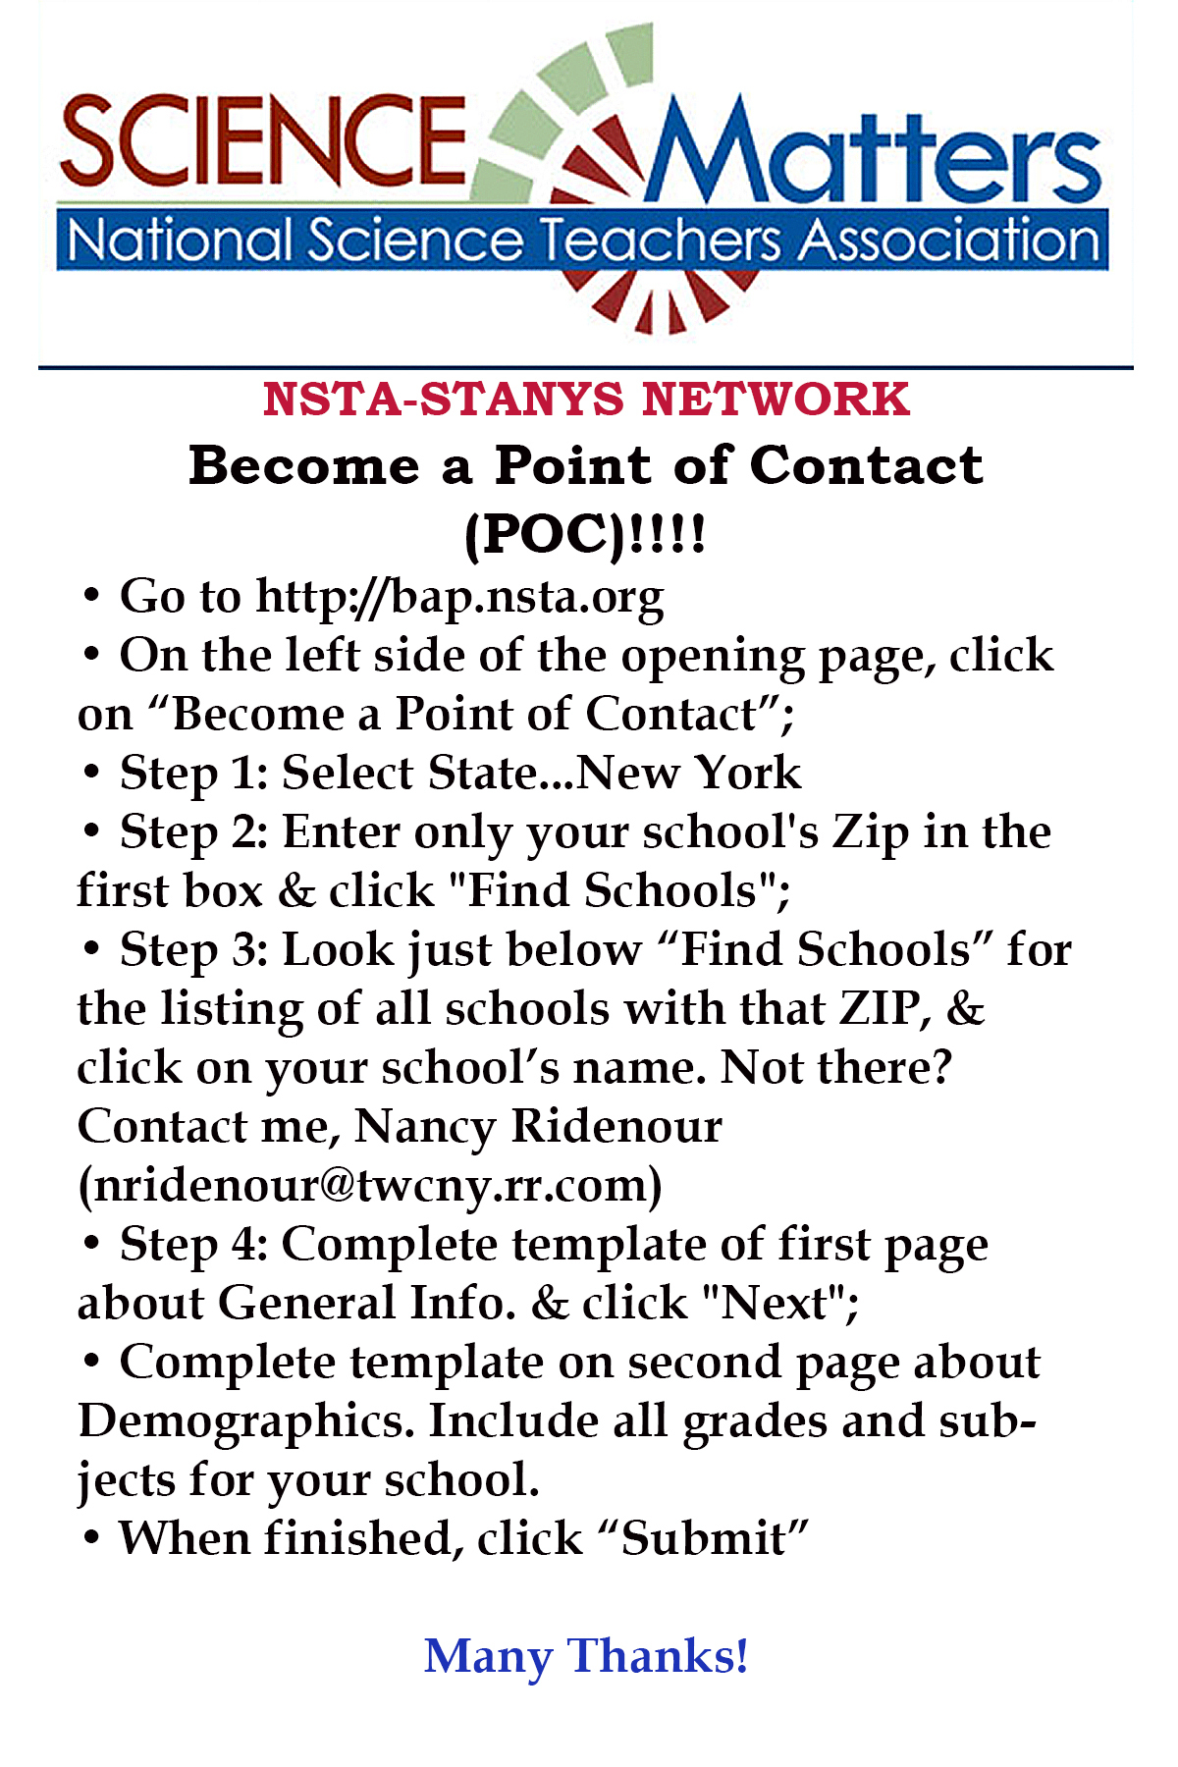 JASON PROJECT

Professional Development Opportunities Connecticut 2018-19

NGSS Series for 2018-19! More Topics, Dates, and Locations Coming! Check Back Often.
Resources and Tools for an NGSS Classroom
Getting ready to or already designing your NGSS units of instruction?
Or just need a little more support in understanding and practicing the NGSS shifts?

We Can Help.
Our 2018-19 Workshop Series provides one and two-day PD to help: educators build their capacity to understand and implement NGSS pedagogy; be introduced to resources, tools, and strategies that can be included in NGSS units of instruction; and offer an opportunity to share challenges, successes, and teaching tips with a network of peers. JASON’s award-winning educational resources are routed in real-world application & phenomena, and address three dimensional teaching and learning (www.jason.org/ngss).
Audience:
- Administrators, curriculum directors, curriculum developers, science coaches, team leaders, and science teachers.
- World of Waves Best Suited for Grades 4-12
- Living Well Best Suited for Grades 6-12
Prerequisites: Although not required, we highly recommend that educators participate in the Next-Gen Science CT Short Course (visit ngss.ccat.us for details) prior to attending a JASON workshop. Other prior PD focused on NGSS, and familiarity with the EQuIP rubric is also helpful. Participants are also encouraged to attend as a team of 2 or more from the same school or district.

Workshop Listings
Two-Day Workshops
World of Waves – NEW Curriculum built in partnership with ONR!
Program Cost: FREE! Sponsored Through Office of Naval Research
Build a deep, working understanding of the physics of waves and their importance in our world. Meet STEM role models ranging from Navy officers to robotics engineers & rock musicians that apply the physics of waves in their work. Visit https://jason.org/world-of-waves for more information.
Participants are eligible to receive a BOSEBuild Speaker Cube Kit of their own to pilot selected activities to explore
- How sound works
- How speakers work
- Frequency and Waveforms
LEARN – Old Lyme, CT 8:30am-3:00pm
Part 2: Friday, March 1, 2019
EASTCONN – Hampton, CT 9:00am – 3:30pm

One-Day Workshops – – MORE TOPICS, DATES AND LOCATIONS COMING!
NEW Biology Curriculum! Living Well
Program Cost: $40.00
Explore the wonders of human biology from the molecular building blocks of life, to cells, organs and organ systems, to the human body as an interconnected whole, and even the behavior of populations—through the prism of human health and disease. Visit https://jason.org/living-well for more information.
LEARN – Old Lyme, CT 8:30am-3:00pm
April 5, 2019
Don’t throw those lessons out with the bathwater! “Tried and true” lessons that have created meaningful experiences for your students for years do not need to be discarded with the advent of new standards. Join us as we share how JASON Learning is redesigning labs to support the transition to an NGSS classroom. Educators will experience two versions of a JASON lab, one created pre-NGSS, and the other a newly designed NGSS version. We will examine specific modifications and the strategies and tools used to make the adaptations through hands-on experience, discussion, and the use of the EQuIP rubric. Toward the end of the session, educators are invited to examine a “tried and true” lesson of their own and apply these new strategies and tools to make future modifications. Come prepared to share ideas and engage in this deconstruct and redesign discourse.
Deconstructing Performance Expectations for an NGSS Classroom
All grade levels
Thursday, March 2, 2017 8:30am – 3:00pm at LEARN, Old Lyme, CT [ Register ]
Tuesday, March 21, 2017 9:00am – 3:30pm at EastConn, Windham, CT [ Register ]
Participants will explore the Next Generation Science Standards in more depth and participate in discussions and analyses of how educators can begin to implement 3-dimensional learning. Participants will be introduced to new lesson planning tools and strategies to begin embracing NGSS pedagogy whether it’s with existing lessons or with new materials and resources. Using activities from JASON’s Climate: Seas of Change, participants will unpack a performance expectation (MS- ESS2-6), specifically looking at how climate is created, climate modifiers, and the relationship between wind patterns and ocean circulation. While using JASON resources to explore what 3-dimensional learning looks like, this experience is intended to empower educators to apply and adapt these tools and strategies to meet the needs of their school’s curricula and classroom settings.

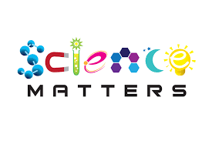
What Is Science Matters? Science Matters is an initiative by the National Science Teachers Association (NSTA) to bring content, news, and information that supports quality science education to parents and teachers nationwide. Science Matters builds on the success of the Building a Presence for Science program, first launched in 1997 as an e-networking initiative to assist teachers of science with professional development opportunities. Building a Presence for Science—now Science Matters—reaches readers in 34 states and the District of Columbia. Why does Science Matter? Science is critical to understanding the world around us. Most Americans feel that they received a good education and that their children will as well. Unfortunately, not many are aware that international tests show that American students are simply not performing well in science when compared to students in other countries. Many students (and their parents!) believe that science is irrelevant to their lives. Innovation leads to new products and processes that sustain our economy, and this innovation depends on a solid knowledge base in science, math, and engineering. All jobs of the future will require a basic understanding of math and science. The most recent ten year employment projections by the U.S. Labor Department show that of the 20 fastest growing occupations projected for 2014, 15 of them require significant mathematics or science preparation to successfully compete for a job. This is why Science Matters. Quality learning experiences in the sciences—starting at an early age—are critical to science literacy and our future workforce. Feel free to publish this information in school newsletters and bulletins, and share it with other parents, teachers, and administrators.

