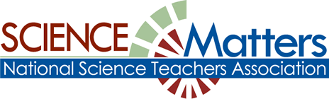

CONNECTICUT SCIENCE CONNECTION
July/August 2015
The Connecticut Building a Presence for Science Network is sustained through the advocacy of the CCAT, Connecticut Science Supervisors Association, and the Connecticut Science Teachers Association

State Coordinator.David Lopath lopath@comcast.net
List Moderator..Eloise Farmer eloisef302@gmail.com

Names and e-mail addresses of our Points of Contact and Key Leaders are not shared with any other entitY

Resources

CSDE’s science curriculum web site.

EQuIP Rubric for Science Released! The Educators Evaluating the Quality of Instructional Products (EQuIP) Rubric for Lessons & Units: Science
Visit the NGSS@NSTA Hub :
The NGSS@NSTA Hub now offers a dynamic version of the Next Generation Science Standards..

Would you like a complete list of grants that has been provided by the National Science Teachers Association? NSTA has put these grant and their deadlines in an easy to follow calendar. It includes: deadline date, description, category, and grade level. To view this list, please visit:
http://www.nsta.org/publications/calendar/
SAVE THE DATE!
CONNECTICUT SCIENCE SUPERVISORS ASSOCIATION: All educators welcome!
DATE: Wednesday, October 7th, 2015
5:30 - 8:00pm
Crowne Plaza Hotel
Cromwell, CT
Speaker: Dianna L. Wentzell,
Commissioner, CT State Department of Education.
Cocktails and Social Time, Meet w/ Sponsoring Exhibitor 4:30-5:30 PM
Buffet Dinner and CSSA Business Meeting 5:30-7:00. For more info, click on: http://www.cssaonline.org/dinner-meetings.html

MORE DATES TO RESERVE FOR THE 2015-16 SCHOOL YEAR:

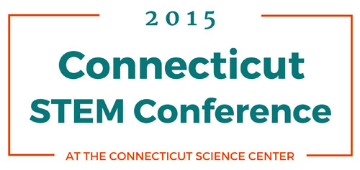
Monday, October 5 at the Connecticut Science Center in Hartford
This fourth annual conference will draw educators from throughout the state at the exciting Connecticut Science Center to explore and discuss ideas and innovations for STEM (science, technology, engineering, and mathematics) curricula.
WE ARE EXCITED ABOUT OUR TWO KEYNOTE SPEAKERS:
Bruce Dixon is an educational innovator, social entrepreneur, youth advocate, former corporate director, motivational speaker and current Chief Executive Officer of the Connecticut Pre-Engineering Program (CPEP).
Dr. Ainissa Ramirez is a science evangelist who is passionate about getting the general public excited about science. She co-authored Newton’s Football: The Science Behind America’s Game and authored Save Our Science: How to Inspire a New Generation of Scientists. For full information, please click on: https://www.ctsciencecenter.org/education/stem2015/

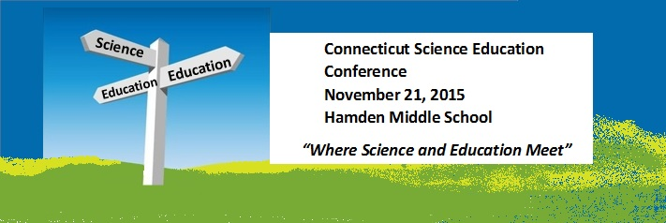Connecticut Science Educators Professional Development Day
Date: Saturday, November 21, 2015 Time: 8:00 AM - 4:00 PM
Hamden Middle School, Hamden, CT.
The 2015 Connecticut Science Educators' Professional Development Day will be held on Saturday November 21 at Hamden Middle School, Hamden, CT. This annual event attracts hundreds of science educators from across the state and throughout New England for workshops, seminars, speakers and commercial exhibitors. This event is co-sponsored by the Connecticut Science Teachers Association and the Connecticut Science Supervisors Association.
The conference program runs from 8:00 AM to 3:30 PM, and it is expected that over 300 K - college science educators from around the state of Connecticut will attend.
This year's theme is <Towards NGSS: Where Science and Education Meet>
For early registration, go to: http://www.csta-us.org/event.htm?id=2azessfl
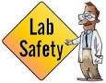
SAVE THE DATES! CONNECTICUT SCIENCE SAFETY NETWORK CSSN 2015-16 WORKSHOP CALENDAR can be found at:
http://www.wesleyan.edu/greenstreet/professionaldev/science_safety/2015-16%20CSSN%202015-16%20Workshop%20Calendar.pdf

PROFESSIONAL DEVELOPMENT
Professional Development Days: Join a NESS Educator and learn some of our programs that you can bring back to your classroom.
Each program is an hour and a half long and is FREE. Registration is limited to 10 people and you must pre-register. To register call 860-535-9362.
Offerings are as follows:
October 7, 2015: Living Lessons
Provide your students with an interactive and “hands-on” living display in your classroom. Instill passion, curiosity and interest that will increase your student’s scholastic performance.
A living aquarium in your classroom becomes an interactive tool with a variety of relevant topics and visual aids for learning biology, anatomy, chemistry, ecology and physics! This
program will show you how NESS can provide you with the needed equipment, lesson plans and the know-how of a simple aquarium set-up. Suitable for all grades.
December 2, 2015: Weird & Wild
Pinchers, antennae, tube feet and more! All organisms have external parts. Different animals use their body parts in different ways to see, hear, grasp objects, and protect themselves. These weird and wild features allow our local animals to survive in the harsh Long Island
Sound habitat. Explore hands-on learning techniques using these concepts and bring them back to your classroom. Suitable for grades K-4.
February 3, 2016: Sailing Sys-STEMS
Sailing is a wonderful avenue to actualize STEM education in an exciting real life application. Learn the physics behind sailing, simple machines or basic navigation principles to name just a few. This class will focus on model sail boats, built from simple materials, including
determining how much cargo your boat can hold, the proper keel to cargo ratio and best rudder shape and placement. Suitable for grades 5-8.
May 4, 2016: Physical Oceanography: Learn about physical properties and dynamics influencing our coastal waters by collecting samples using our sampling tools including a Van Dorn Bottle and an Eckman Grab. Measure the quality of the water by determining density, temperature, salinity and dissolved oxygen,
and analyze findings using the scientific method. Apply discoveries to understand trends occurring in our oceans, harbors, estuaries and lakes surrounding where we live. Suitable for grades 9-12.
New England Science & Sailing, P.O. Box 733 · 70 Water Street, Stonington, CT 06378, 860-535-9362 · office@nessf.org www.nessf.org

IF YOU TEACH COURSES WITH CHEMISTRY OR PHYSICS CONTENT, WE NEED YOUR EXPERTISE.
Currently, our website shares 30 K-6 lessons with physics content and 32 K-6 lessons with chemistry content. In anticipation of increased numbers of K-6 teachers sharing lessons in 2015-16, we would like to have more physical science content specialists who would consider viewing a video of a K-6 lesson, meeting online with the teacher who taught the lesson to discuss the lesson's science content, and then sharing the recorded discussion on our website for the benefit of K-6 teachers nationwide. (We make all our video recordings at-a-distance).
Meanwhile, you can get our Summer 2015 Newsletter, share it, and give us your ideas. Our Summer Newsletter focuses on the past, present, and future of the "Teachers Helping Teachers Teach Inquiry Science: Just ASK" project and invites suggestions and questions.
Teachers currently sharing their adapted science inquiry lessons always appreciate comments and suggestions. Have a great summer.
----------------
Charles Matthews, Academic Research Scientist, University of Missouri at St. Louis. Email to schedule Skype or PolyCom Session, matthewscc@umsl.edu
Skype: dr.charles.c.matthews PolyCom IP Address 98.172.76.67

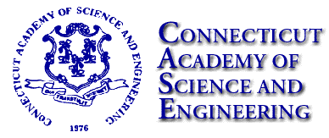
The 2015 CASE Summer Bulletin is now available. In this issue:
•Connecticut’s Evolving Innovation Ecosystem
•Yale’s Joan Steitz Awarded 2015 Connecticut Medal of Science
•News from the National Academies:
oNew Report Urges US to Strengthen Innovation, Productivity, Workforce Training
oFAA Should ‘Reset Expectations’
oBattery Technologies for Automotive Applications
oCognitive Aging’ Poses Major Health Issue for Older Americans
oPersonalized Medical Robots: The Next Generation
oIOM Report Recommends ‘Vital Signs’ to Score Progress on US Health Care
•In Briefs: Science and Technology News from Around the State www.ctcase.org/

STEM PROGRAM AT CENTRAL CONNECTICUT STATE UNIVERSITY! The MS in STEM Education for Certified Teachers will prepare certified teachers in the trans-disciplinary areas of Science, Technology, Engineering and Mathematics (STEM). Courses are aligned with National and/or CT state content standards in each discipline: Science, Technology, Engineering, and Math, and the Common Core for Mathematics and Language Arts. Does not lead to CT state teacher certification or cross-endorsement. In line with the STEM philosophy, courses will integrate the STEM disciplines and provide teachers with the skills necessary to move away from the traditional way of teaching discrete subjects towards a more comprehensive way of addressing the science, technology, engineering, and mathematics disciplines for use in the classroom to prepare students for 21st century college skills and career readiness. Details can be found at: http://ccsu.smartcatalogiq.com/current/Undergraduate-Graduate-Catalog/Masters-Degree-Programs/STEM-Education-for-Certified-Teachers-M-S . For further information, contact Marsha Bednarski at: bednarskim@ccsu.edu
Admission Requirements:
The MS STEM Education Program is for certified teachers who hold a bachelor's degree from a regionally accredited institution of higher education. Applicants must also have a minimum undergraduate GPA of 2.70 on a 4.00 point scale (where A is 4.00), or its equivalent, and good standing (3.00 GPA) in all post-baccalaureate course work. The admissions application, application fee, and official transcripts from each college and university attended (except Central Connecticut State University) must be submitted to the Graduate Recruitment Admissions Office.

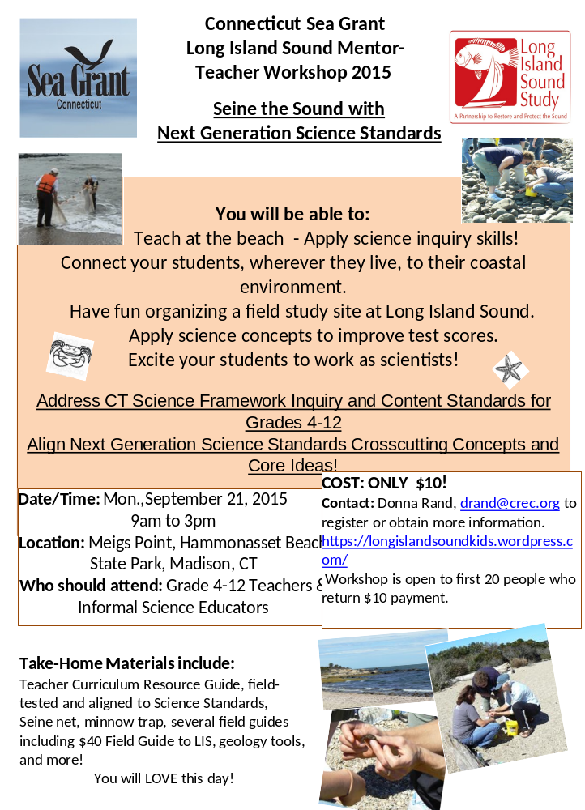
Date/Time: Mon.,September 21, 2015 (see next page left column for details)
9am to 3pm
Location: Meigs Point, Hammonasset Beach State Park, Madison, CT
Who should attend: Grade 4-12 Teachers & Informal Science Educators
COST: ONLY $10!
Contact: Donna Rand, drand@crec.org to register or obtain more information.
https://longislandsoundkids.wordpress.com/
Workshop is open to first 20 people who return $10 payment.

WE ARE LOOKING FOR RETIRED SCIENCE CONTENT SPECIALISTS willing to support K-6 science teachers on our free website at http://justaskateacher.com . Our project asks the science content specialist to (1) first view a video of a K-6 science lesson, (2) then meet with the teacher online to discuss the science content, and (3) finally, allow us to post the video of the session with the teacher so that other K-6 teachers can benefit. Interested? Please let us know.

Thanks and have a great summer.
Charles Matthews
Academic Research Scientist
University of Missouri at St. Louis
Email to schedule Skype or PolyCom Session
matthewscc@umsl.edu
Skype: dr.charles.c.matthews
PolyCom IP Address 98.172.76.67

EARTH SCIENCE WEEK 2015 CONTESTS

The American Geosciences Institute is sponsoring a series of contests to celebrate Earth Science Week 2015. This year's celebration takes place Oct. 11-17, 2015.

Earth Science Week 2015 Photography Contest -- Open to All Ages
http://www.earthsciweek.org/contests/photography/index.html
Geoscientists study our planet’s geosphere (land), hydrosphere (water), atmosphere (air), and biosphere (living things). These spheres -- or Earth systems -- continually affect and influence one another. With a camera, you can capture evidence of the dynamic impact of change processes in your home, neighborhood, school, workplace or local public spaces. In a photo, show at least one Earth system affecting another Earth system in your community.

Earth Science Week 2015 Visual Arts Contest -- Open to Students in Grades K-5
http://www.earthsciweek.org/contests/visualarts/index.html
Earth science is the study of Earth systems -- land, water, air and living things. Scientists pay special attention to the ways these things affect each other, such as the way wind shapes the landscape or falling rain nourishes plants. Use artwork to show how land, water, air and living things interact in the world around you.

Earth Science Week 2015 Essay Contest -- Open to Students in Grades 6-9
http://www.earthsciweek.org/contests/essay/index.html
Since the earliest hand-drawn maps and diagrams, “visualization” has been an important way of explaining and understanding the interactions of land, water, air and living things. Earth scientists today use more sophisticated technology to monitor and represent these Earth systems -- the geosphere, hydrosphere, atmosphere and biosphere. In an original essay no more than 300 words in length, explain one way that geoscientists’ use of cutting-edge visualization is advancing Earth science today.

The entry deadline for all three contests is Oct. 16, 2015. Visit the contest websites for full details.
If you have any questions about these contests, please email the Earth Science Week staff at info@earthsciweek.org.

A Science Argumentation rubric has been developed by Mary Lou Smith and her colleagues. If anyone tries it out, they would really like to get some feedback! To get a copy, you can request an updated one by email from Eloise Farmer at eloisef302@gmail.com

YOU CAN HELP A STUDENT WITH HER PROJECT: I am a candidate for a Masters of Science in Science Education degree through Montana State University. For my capstone project, my contribution is to research current science issues and teacher resources for the Next Generation Science Standards (NGSS).

My goal is to connect scientists and educators through this project, including with conversations like scientist interviews and teacher forums. Part of this project includes surveying teachers on their current knowledge of NGSS and access to technology.

This is a special request to ask you to complete this voluntary survey, which takes approximately 10-15 minutes, with optional fields and is confidential. Here is the survey link: http://teachingcontinuum.com/survey

This survey is open to any and all teachers, regardless of the topic or if they are involved with NGSS. Please feel free to send along to any of your peers. I'm afraid I don't have much to offer as a thank you other than a genuine thank you, so thank you.

If you are interested in being involved with the teacher forums, I think this is a place for you to share! Let me know if you have any questions and thank you again for your tremendous support.
Jess

Connecticut Green LEAF Schools has been awarded a Teacher Quality Partnership Grant through the CT Office of Higher Education. . More information about Connecticut Green LEAF Schools can be found at www.ctgreenleaf.org

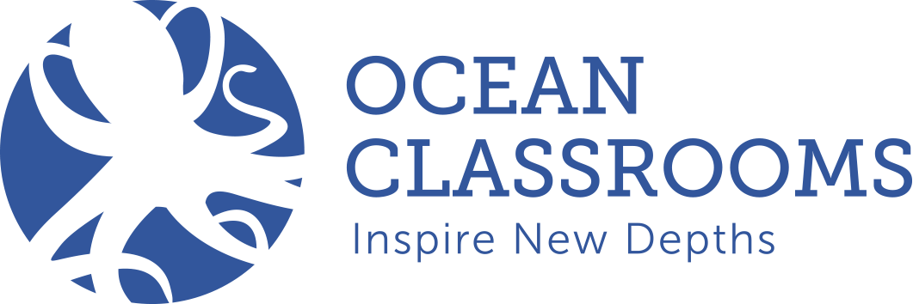
You can sign up for a free 30-day trial to check out a new online course, Marine Science 101. It is a comprehensive online (with offline components), high school, semester-long course.
https://oceanclassrooms.com/learning/marine-science-101

We also have a free Ocean Literacy online course on our home page: https://oceanclassrooms.com/ as well as a free portal with live ocean data from around the globe. https://oceanclassrooms.com/sciencenodes
cyndi@oceanclassrooms.com

NEW MATERIALS AND PROJECTS FROM NASA! https://www.nasa.gov/audience/foreducators/index.html

NGSS K-8 Evidence Statements Now Available The NGSS Evidence Statements for elementary grades (K-5) and middle grades (6-8) are now available. These statements were developed and reviewed by educators and scientists, including many members of the NGSS writing team. The evidence statements are intended to identify clear, measurable components that, if met, fully satisfy each performance expectation (PE) described within the NGSS. Given that each PE is three-dimensional, the statements describe how students can use the practices, crosscutting concepts, and disciplinary core ideas together to demonstrate proficiency on the PEs by the end of instruction. They are not meant to limit or dictate instruction and were written to allow for multiple methods and contexts of performance, including students' performance on multiple related PEs together at the same time.

For more information, see the Introduction and Overview, which applies to the evidence statements for all grade levels. Additional materials, including appendices for K-2, 3-5, and middle school are coming soon.

AN IMPORTANT LINK FOR EDUCATORS TO VISIT FOR INFORMATION ON THE STATUS OF SCIENCE STANDARDS IN CONNECTICUT: http://www.sde.ct.gov/sde/cwp/view.asp?a=2683&Q=333862
In 2012, the U.S. Department of Education (USED) granted the Connecticut State Department of Education (CSDE) a three-year flexibility request from certain requirements of the Elementary and Secondary Education Act of 1965 (ESEA), also known as the “No Child Left Behind Act” The waiver provided Connecticut educators with the ability to advance state and local efforts for school improvement and utilize federal resources to support learning for all students. As part of the flexibility request, CSDE developed a state plan designed to ensure that all students are prepared to succeed in college and careers, to close achievement gaps through proven and impactful interventions in low performing schools and districts, and to support educators in reaching high professional standards and receiving meaningful development opportunities in order to ensure all students have access to effective instruction. The USED has invited the State to renew our request for an additional three years in order to sustain our progress towards these goals.
The flexibility renewal submission continues many of the major initiatives outlined in Connecticut’s approved plan and seeks to strengthen and evolve others. Many of the proposed modifications have been presented and discussed at various stages with some educational stakeholders. Last month, the CSDE solicited public comment from all interested parties and persons regarding the proposed ESEA flexibility request. The Department invited feedback on the proposed renewal request which addresses the USED’s three prescribed principles. Provided for information was
- an overview of Connecticut's progress made to date in the implementation of the existing, approved ESEA flexibility request;
- a listing of the USED’s required components that must be addressed in the ESEA flexibility waiver renewal application; and
- an overview of the key initiatives to be continued or modified that address the required components in the renewal application.
This sets up an accountability system with many parts, including standards, the measures used to assess schools and districts, the implications for different categories of schools, and the role of teacher evaluation systems.
At a recent meeting (Mar 3), CSDE staff shared with some science educators some of the science specific issues addressed in the State proposal to the Federal Government in a request for an extension of the waiver. One of the most significant changes is in how science is “counted” in the overall measure of schools and districts. For the 2012 and 2013 School/District Performance Index scores, CAPT science, reading, writing, math were all counted equally. But for CMT Science, it was only used for tested grades (5,8), effectively making science worth 1/10, reading 3/10, writing 3/10, math 3/10.
In the future this would change, and each subject would get its own index score (based on CMT/CAPT scale scores, not performance levels as before), so that science will count the same as literacy and math. http://www.sde.ct.gov/sde/lib/sde/pdf/esea/principle_2_performance_and_turnaround_esea_flex_renewal_031715.pdf
"Science index scores will be generated based on results from the Connecticut Mastery Test (CMT) assessments and the Connecticut Academic Performance Test (CAPT) assessments (both the standard form and Skills Checklist) in all available tested grades (i.e., 5, 8, and 10) in the district/school. This indicator weights tested subjects equally” However, Science is NOT counted in the growth part of the achievement score
• Also of note is that 9th grade passing rates count for both high schools AND 8th grade schools
• College and Career Readiness courses could include science AP or UCONN ECE courses or CTE certificates.
In Principle I of the waiver, there is some discussion on an anticipated adoption of NGSS standards, along with a mention of training , presentations, and committee work going on this spring,
Also important to note that CSDE has put forth an RFP for 2016-19 CMT/CAPT science tests which has a draft proposed timeline for transition: online testing, and a switch to NGSS standards testing by 2019.(33% in 2017, 66% in 2018, 100% in 2019). This timeline also shows high school science testing shifting to 11th grade in 2019. See pg.4 and the timeline on pg 27 of the RFP at http://www.sde.ct.gov/sde/lib/sde/pdf/rfp/15sde0001rfp_cmt_capt_science.pdf
(Thanks to Rich Therrien for the above information)

What Is Science Matters? Science Matters is an initiative by the National Science Teachers Association (NSTA) to bring content, news, and information that supports quality science education to parents and teachers nationwide. Science Matters builds on the success of the Building a Presence for Science program, first launched in 1997 as an e-networking initiative to assist teachers of science with professional development opportunities. Building a Presence for Science—now Science Matters—reaches readers in 34 states and the District of Columbia. Why does Science Matter? Science is critical to understanding the world around us. Most Americans feel that they received a good education and that their children will as well. Unfortunately, not many are aware that international tests show that American students are simply not performing well in science when compared to students in other countries. Many students (and their parents!) believe that science is irrelevant to their lives. Innovation leads to new products and processes that sustain our economy, and this innovation depends on a solid knowledge base in science, math, and engineering. All jobs of the future will require a basic understanding of math and science. The most recent ten year employment projections by the U.S. Labor Department show that of the 20 fastest growing occupations projected for 2014, 15 of them require significant mathematics or science preparation to successfully compete for a job. This is why Science Matters. Quality learning experiences in the sciences—starting at an early age—are critical to science literacy and our future workforce. Feel free to publish this information in school newsletters and bulletins, and share it with other parents, teachers, and administrators.

